Getting Started 学习笔记

harli

2015/1/7

# [Quick Start](https://confluence.jetbrains.com/display/IntelliJIDEA/Quick+Start)

## [Basics and Installation](https://confluence.jetbrains.com/display/IntelliJIDEA/Basics+and+Installation)

### 根据你的平台下载IntelliJ IDEA

* IntelliJ IDEA is cross-platform and runs on Windows, Mac OS X and Linux.
* You can download the latest version for any platform from the [official website](http://www.jetbrains.com/idea/download/index.html).
* Earlier versions are available for download [here](http://confluence.jetbrains.com/display/IntelliJIDEA/Previous+IntelliJ+IDEA+Releases).

### 选择Community Edition or Ultimate

* Do you develop for Java, Groovy, Scala or Android? Get the free and open-source IntelliJ IDEA Community Edition.
* Do you develop for web or enterprise? Get a free 30-day trial for IntelliJ IDEA Ultimate with an exclusive set of developer tools and frameworks supported.
* For more details read the feature-by-feature [editions comparison](http://www.jetbrains.com/idea/features/editions_comparison_matrix.html).

### How can I get IntelliJ IDEA Ultimate for free?

* If you contribute to an open-source project, show us your commits and get a personal license for free!
* If you are a student, ask your instructor or trainer to get a classroom license for free!
* If you work for a company, convince your manager to [buy](http://www.jetbrains.com/idea/buy/index.jsp) a commercial license!

### How do I install IntelliJ IDEA on my platform?

* Windows: Run the .exe file and follow steps of the Installation Wizard.
* Mac OS X: Open the .dmg package and drag/copy IntelliJ IDEA to the application folder.
* Linux: Unpack .tar.gz archive and run bin/idea.sh.

### How do I customize the IDE at first launch?

* When you launch the IDE for the first time, it will offer you to choose the plugins you would like to use. Later you will be able to change your selections in Settings → Plugins.

### I'm used to a different IDE. What to do?

* If you've worked with Eclipse before, we suggest that you read the [migration guide](http://confluence.jetbrains.com/display/IntelliJIDEA/IntelliJ+IDEA+for+Eclipse+Users). Get ready for your life to change forever (in a good way)!

### How do I get started with IntelliJ IDEA?

* Check out tutorials and how-to guides at this [dedicated website](http://confluence.jetbrains.com/display/IntelliJIDEA/Tutorials).
* Subscribe to our [YouTube channel](http://youtube.com/IntelliJIDEAVideo) and watch the latest video tutorials.
* See the keymap in Help → Default Keymap Reference on our [website](http://www.jetbrains.com/idea/documentation/index.jsp).

### How do I submit the feedback?

* The easiest and most efficient way to be heard is to submit an issue into our [issue tracker](http://youtrack.jetbrains.net/issues/IDEA).
* Have a problem or just an idea how to make the user experience better? - Don’t hesitate to create an issue. Our developer team will come to your help shortly.
* Another option to submit feedback or get help from developer community is to ask on the [discussion forum](http://devnet.jetbrains.net/community/idea). There's a good chance that someone already knows a solution.

## [User Interface](https://confluence.jetbrains.com/display/IntelliJIDEA/User+Interface)

|  |  |
| --- | --- |
|  | User interface is not only what you see, but also what you interact with every single day of your coding. That’s why it’s important to know exactly how it works and what benefits it provides to you to make you more productive. |

### User interface for higher productivity

By default IntelliJ IDEA shows you the navigation toolbar, tool window bars and the project view. This is the minimum set of what you can use to navigate over the project files and developer tools.

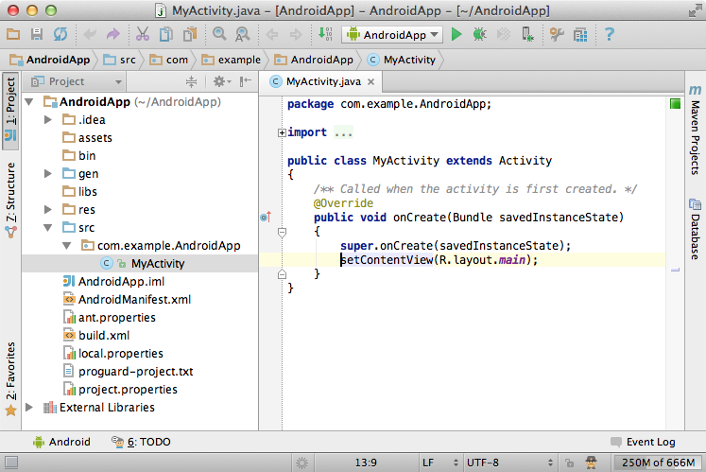

Some of tool windows have a number in title. You can show or hide a tool window by pressing this number with Alt (Cmd for Mac). The navigation bar can be hidden to bring more space for the editor. Later we will show you how to access it quickly via a shortcut. The tool window bar can be also hidden by clicking the icon in the left bottom corner.

Tool windows：可以通过Alt+对应数字，来显示或隐藏（Mac时，alt对应为Cmd），或通过快捷键访问，或通过单击左下角的图标来隐藏。

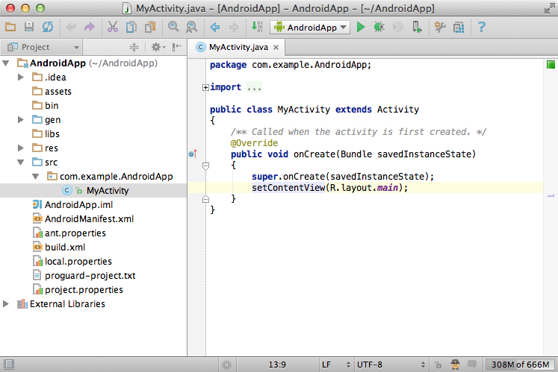

If you want to open a tool window when the tool window bar is hidden you can press Alt (Cmd for Mac) twice. When you hide everything you don’t need, the IDE looks just like a text editor, a very powerful one at that. You can always maximize the editor by pressing Shift +Ctrl + F12 (Shift + Cmd + F12 for Mac).

当tool window bar隐藏起来时，可以通过两次按Alt键来打开。

通过Shift +Ctrl + F12 最大化编辑器。

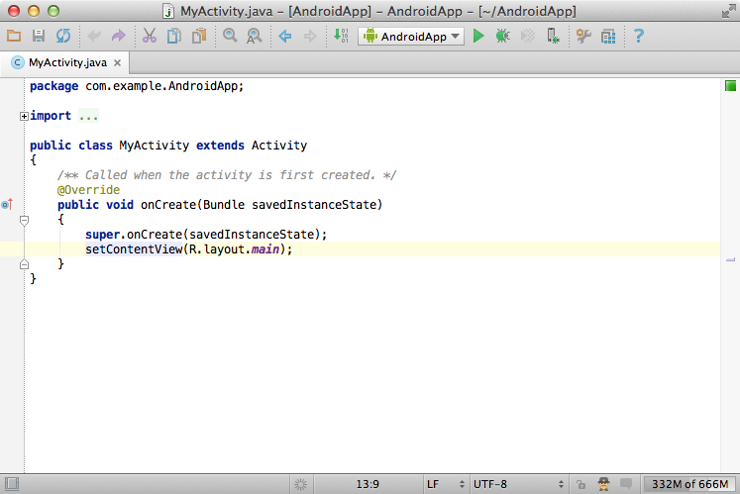

### No switching between perspectives

IntelliJ IDEA has no perspectives like other IDEs do (e.g. Eclipse). It means that you don’t need to switch between different workspace layouts manually to do different tasks. The IDE follows your context and brings up the corresponding tools automatically. Since there are no perspectives, the shortcuts and actions stay the same all the time.

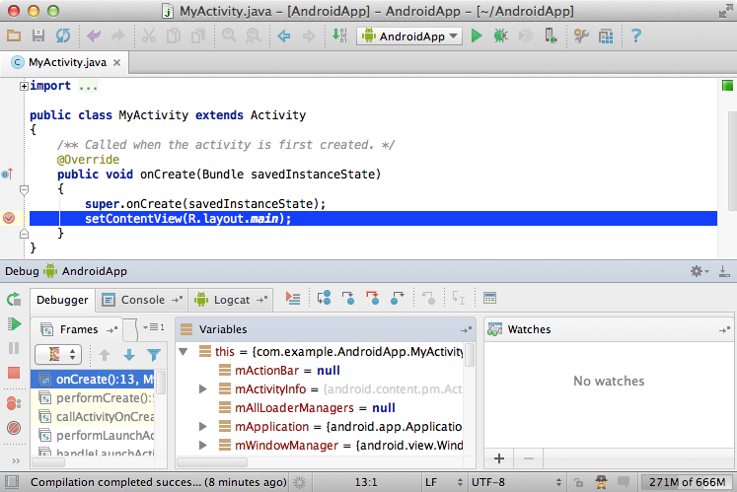

### Speed search快速查找

Most components in IntelliJ IDEA provide speedy search. This feature allows you to filter the list or navigate to a particular item by using a search query. If your focus in the project view tool window and you would like to navigate to some item without using the mouse — just start typing its name and the IDE will do what you want.

大部分组件提供快速查找功能。能通过快速查找功能过滤列表或导航到特定项。

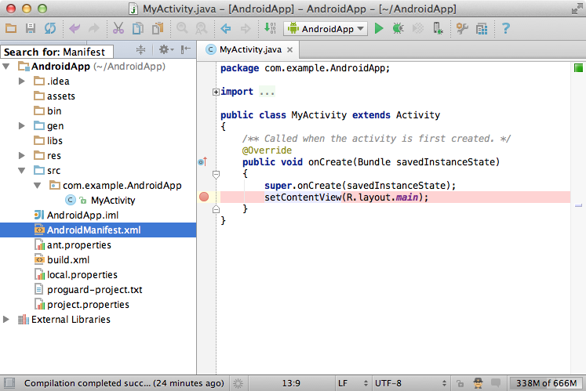

### Multiple windows

If you want to work with some files in a separate window, just drag the editor tab out of the window and the IDE will detach this tab into a window. You can easily drag your tabs from one window to another.

可以将文件放到独立的窗口：通过拖拽方式。

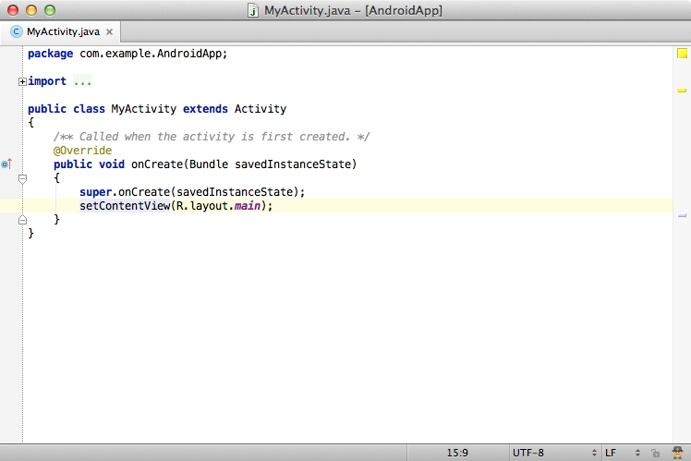

### Darcula color scheme

Since v12, IntelliJ IDEA provides a native darker look and feel called Darcula. You can always change your look and feel in Settings →Appearance → Theme.

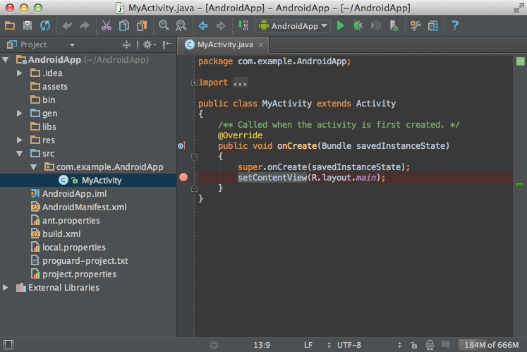

### Find action by name

If you don’t know how to call a particular action, you can find it by name via Shift + Ctrl + A (Shift + Cmd + A for Mac).

Action的快捷键：**Shift + Ctrl + A**通过名字进行查找。

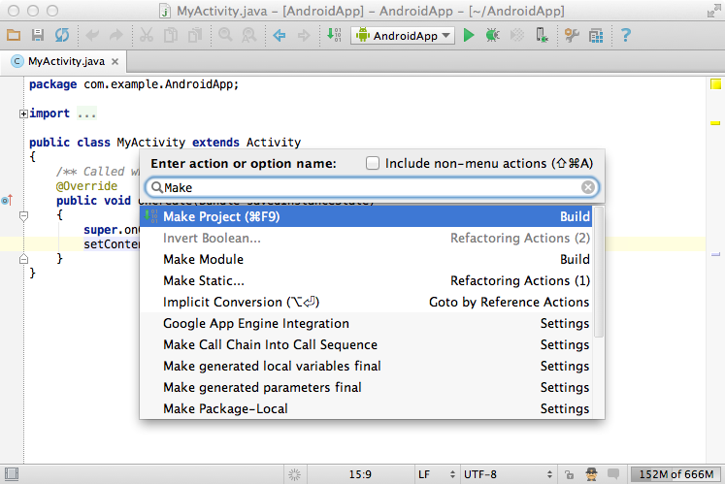

## [Editor Basics](https://confluence.jetbrains.com/display/IntelliJIDEA/Editor+Basics)

|  |
| --- |
| While developing in IntellIJ IDEA you will spend a bulk of your time working in the editor. That’s why it is worth to know it’s basic features. |

### **1. Settings by default**

The editor highlights matching brackets, scope, vertical indent guides and usages of the element at the caret by default. You can change this and more in Settings → Editor and Settings → Editor → Appearance.

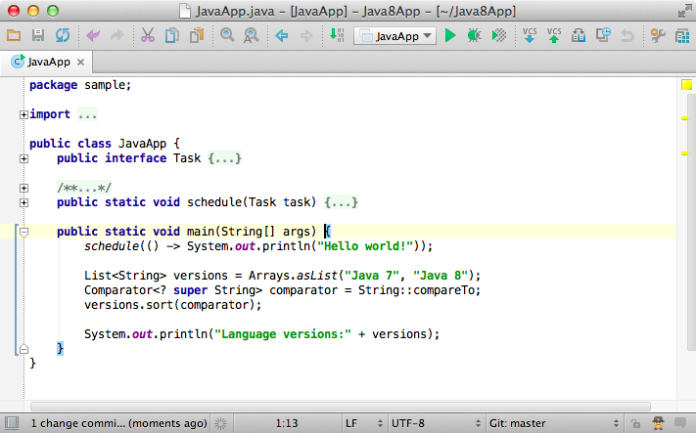

Two other options worth mentioning are:

* Allow placement of caret after end of line, enabled by default. If you find this option annoying, you can disable it in the settings.
* Show line numbers; disabled by default.

### **2. Saving changes**

One of the greatest editor features that new users find unusual and later brilliant is how it saves changes. IntelliJ IDEA does it automatically so you don’t need to worry about it. If you decide to roll-back some of your changes, you can always do it by using [Local History](https://confluence.jetbrains.com/display/IntelliJIDEA/Local+History).

### **3. Status bar indicators**

On the status bar you can find useful information for the currently opened file, such as type of line endings (Windows/Unix), the encoding, the current branch in version control and the read-only status.

### **4. Method separators**

One more useful option (disabled by default) is showing method separators.

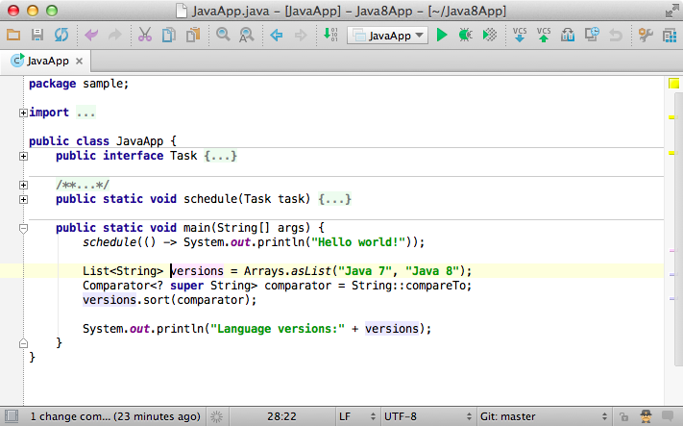

### **5. Structural selection**

A definite must-know to be even more productive. Structural selection allows you to select expressions based on grammar. By pressing Ctrl +W (Cmd + W for Mac) you keep expanding your selection (starting from the caret). And vice versa, you can shrink it by pressing Shift +Ctrl + W (Shift + Cmd + W for Mac).



### **6. Column selection**

Column selection with mouse is available when you hold Alt. If you decide to use column selection by default, you can enable it via Edit →Column Selection Mode.

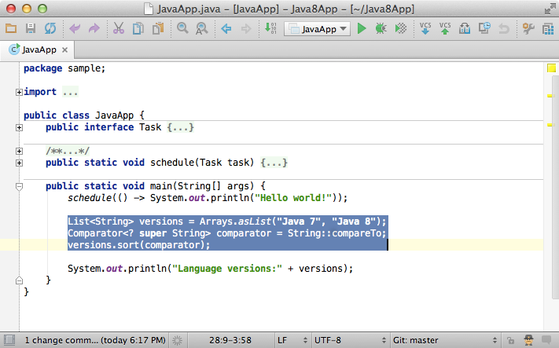

### **7. Folding**

Another neat feature of the editor is folding. You can fold and unfold fragments of code by pressing Ctrl + . (Cmd + . for Mac).



### **8. Other useful actions**

* Move the current line of code (or selected block) via Shift + Ctrl + Arrows (Shift + Cmd + Arrows for Mac).
* Duplicate a line of code (or selected block) via Ctrl + D (Cmd + D for Mac)
* Remove a line of code (or selected block) via Ctrl + Y (Cmd + Y for Mac)
* Comment or uncomment a line of code (or selected block) via Ctrl + / (Cmd + / for Mac) and Shift + Ctrl + / (block comment for selected code).
* Optimize imports via Ctrl + O (Cmd + O for Mac).
* Find in the currently opened file via Alt + F3 (F3 to the next match rance and Shift + F3 to the previous match). Or, replace in the currently opened file via Ctrl + R (Cmd + R for Mac).
* Enable/show soft-wraps, disabled by default.
* Paste from stack via Shift + Ctrl + V (Shift + Cmd + V for Mac).
* Navigate between opened tabs via Alt + Arrows (Ctrl + Arrows for Mac).

## [Code Completion](https://confluence.jetbrains.com/display/IntelliJIDEA/Code+Completion)

|  |
| --- |
| Focused on developer productivity, IntelliJ IDEA provides powerful features for code completion. However, as there are several code completion features, it is important to learn how they work and when it’s best to use each one. |

### **1. Basic completion**

Basic completion offers most trivial suggestions for variables, types, methods, expressions, etc. It is worth mentioning that IntellIJ IDEA provides Basic completion automatically when you start typing. This means you don’t need to press any shortcuts to see suggestions. But if you want to call it explicitly, simply press Ctrl + Space shortcut.

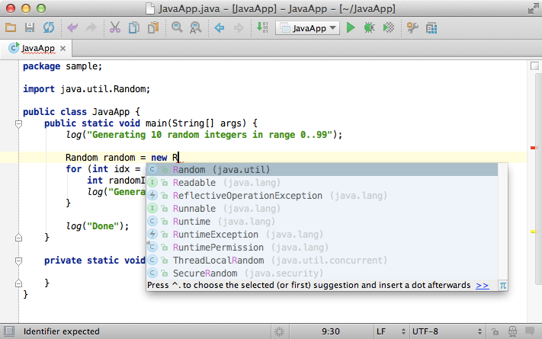

Note, when you call Basic completion twice, it shows you more results, including private members.

### **2. Smart completion**

Additionally to Basic completion, IntelliJ IDEA provides Smart completion which is much more advanced and comprehensive. Smart completion is aware of the expected type and data flow and offers the option relevant to the context. To call Smart completion, press Shift + Ctrl +Space.

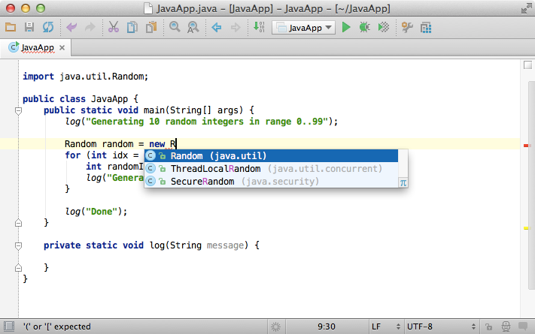

Note that when you call Smart completion twice, it shows you more results, including chains and non-imported static members.

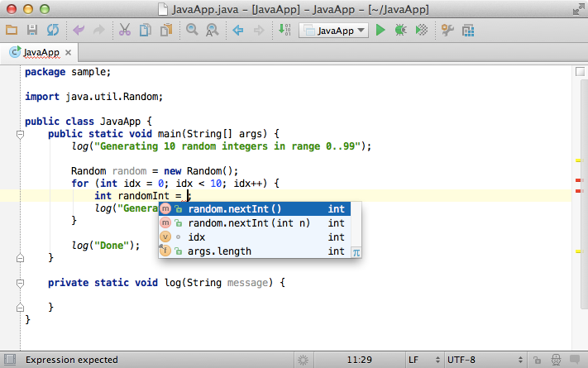

### **3. Completion with Tab**

If you select an item from the suggestion list by clicking Tab, it will overwrite the identifier at the caret, instead of just inserting the suggestion. This is helpful if you’re editing a part of an identifier, such as a file name.



### **4. Statement completion**

Statement completion automatically adds missing parentheses, brackets, braces and adds the necessary formatting. To complete a statement, just press Shift + Ctrl + Enter (Shift + Cmd + Enter for Mac).



### **5. Negating completion**

If you select a boolean item from the suggestion list with !, IntelliJ IDEA automatically adds the negation operator to the result.



### **6. Middle matching**

IntelliJ IDEA also supports so-called Middle matching. It means that you don’t necessarily need to type an identifier from the beginning. For example, if you only remember a part of the name, just type it and IntelliJ IDEA will still find the right matches for you.

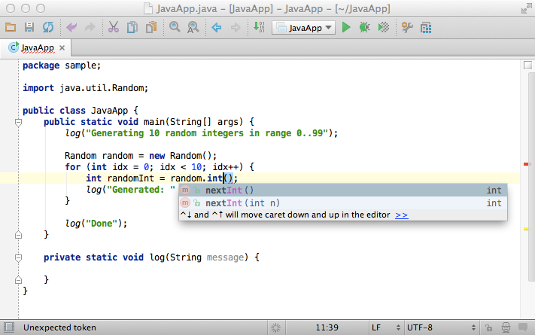

### **7. Parameter info**

If you want to see the suggested parameters for any method or constructor, just press Ctrl + P (Cmd + P for Mac). IntelliJ IDEA shows parameter info for every overloaded method or constructor, and highlights the best match for the parameters already typed. This helps you to choose between overloaded options and compare your input with what’s expected.

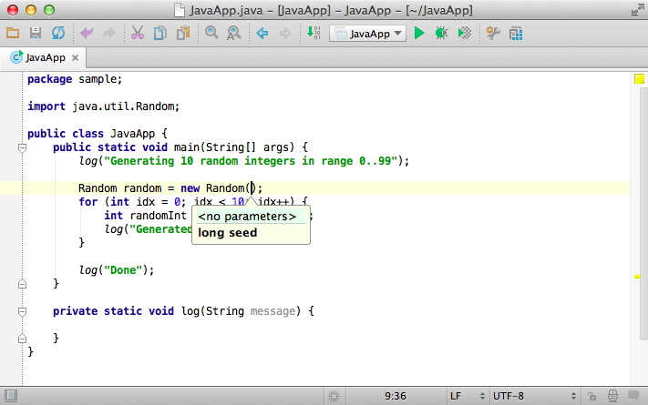

### **8. Quick popups**

Quick popups such as Quick documentation (via Ctrl + Q, or Ctrl + J for Mac) or Quick definition (via Shift + Ctrl + I, or Shift +Cmd + I for Mac) are available when you browse suggestions in code completion.

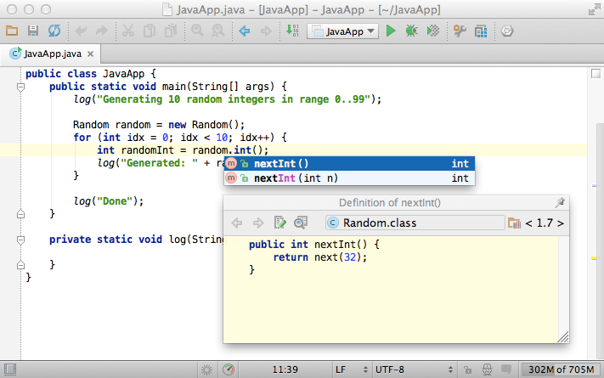

### **9. Exclude from completion**

If you are fed up with some class constantly appearing in the suggestion list, IntelliJ IDEA can exclude this class or even a whole package so you never see it again. Just press Alt + Enter on an item and confirm the exclusion. You can always turn it back in Settings → Editor →Auto Import.

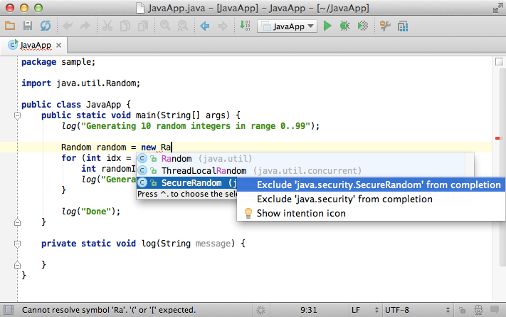

### **10. Completion settings**

If you want to change the default settings for completion you can do it via Settings → Editor → Code Completion.

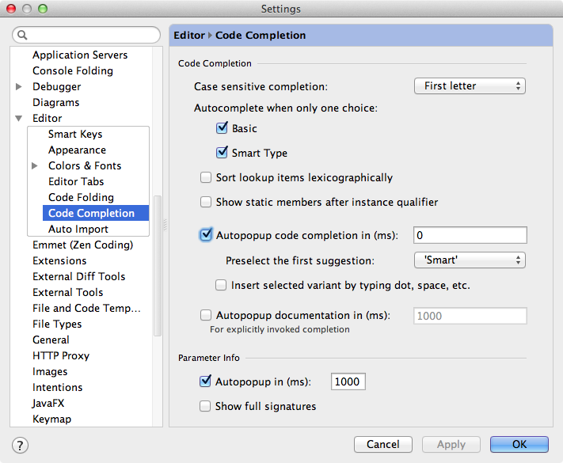

## [Navigation](https://confluence.jetbrains.com/display/IntelliJIDEA/Navigation)

|  |
| --- |
| Navigation means how fast you switch between the pieces of code you are working on. The faster you switch the more productive you are. Here is a list of notable features which make your navigation experience smooth. |

### **1. Recent files**

Most of the time you work with a final set of files. It means you have to switch between them quickly all the time. The real time-saver here is action called Recent files via Ctrl + E (Cmd + E for Mac). By default the focus is on the last accessed file. In the meanwhile you can open any tool window through this action.

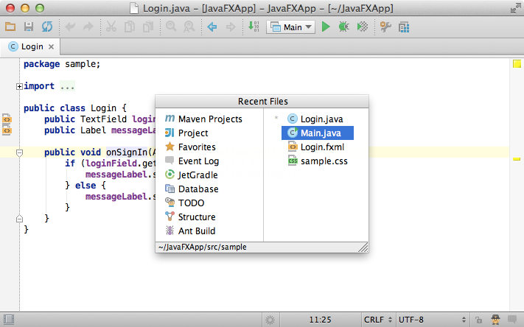

Another useful feature similar to Recent files is Recently edited files, available via Shift + Ctrl + E (Shift + Cmd + E for Mac). This is the easiest way to get back to the code you are working on.

### **2. Structure**

When you are not switching between files you probably navigate within a file. The shortest way to do it is to press Ctrl + F12 (Cmd +F12 for Mac). The popup shows you the structure of file and allows you quickly navigate to any item. Just as always you don’t need to touch mouse.

Note that the speed search works here as well. The second press of the shortcut displays inherited members.

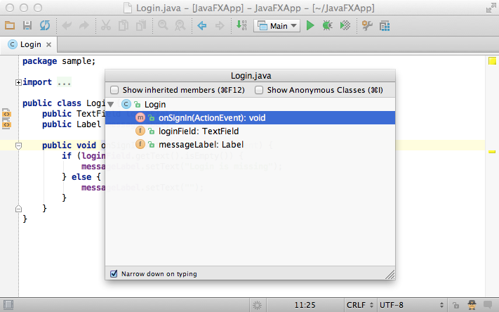

### **3. Switcher**

Just like the task switcher in an operating system IntelliJ IDEA provides a switcher between opened files and tool windows. The action is available via Ctrl+Tab.

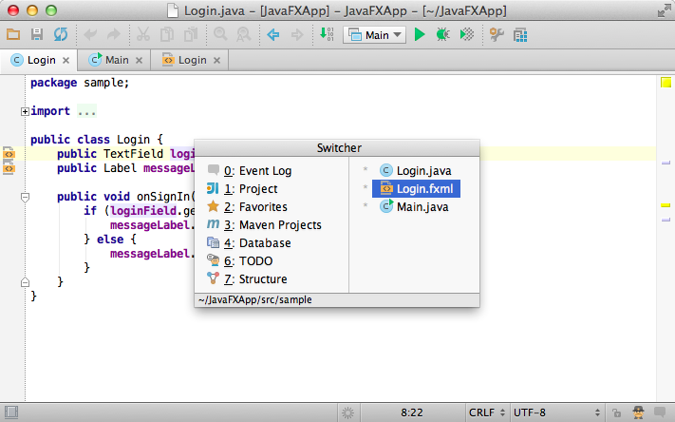

### **4. Jump to navigation bar**

Another useful feature worth to mention is Jump to navigation bar via Alt + Home (Alt + ↖ for Mac). The navigation bar in the top of the window is useless most of the time. That’s why developers usually hide it and call on demand via a shortcut.

The navigation bar supports the speed search and other actions, such as code generations, documentation popup, etc.

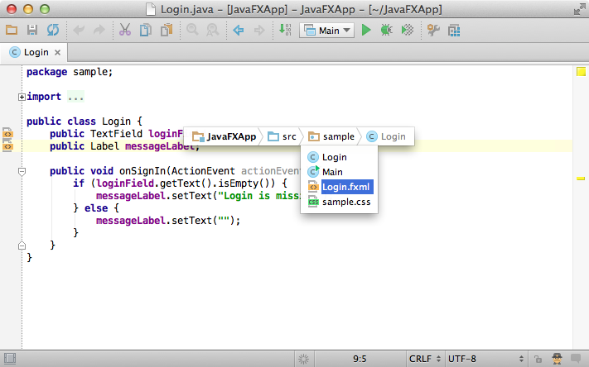

### **5. Navigate between methods**

If you need to jump over the methods quickly just press Alt + ↑↓ (Ctrl + ↑↓ for Mac).



A similar action for navigating between braces is available via Ctrl + { and Ctrl + } (Cmd + { and Cmd + } for Mac).

### **6. Navigate to anything**

The next feature which practically one of the most used in IntelliJ IDEA is Navigate to Class, File and Symbol.

This feature is available via Ctrl + N (Cmd + N for Mac) supports sophisticated expressions, including camel humps, path, line navigate to, middle name matching and many more. If you call it twice it shows you the results out of the project classes.

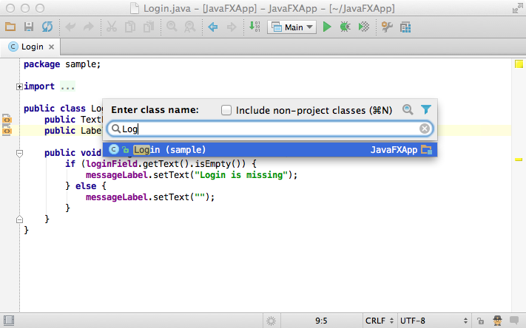

Just like for classes it works for files as well, via Ctrl + Shift + N (Cmd + Shift + N for Mac). The results are sorted by the relevance to the expression.

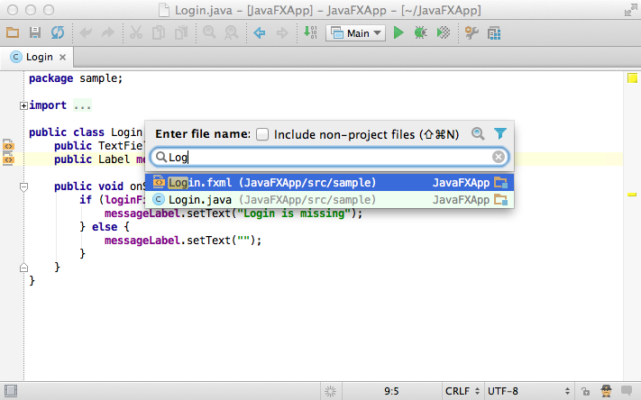

And finally the most tricky feature is to navigate to a symbol via Ctrl + Alt + Shift + N (Alt + Cmd + Shift + N for Mac). The IDE constantly maintains the index of all symbols in the project (and within libraries as well) for quick resolve and navigation. So you can type an expression and find a method or a field you need in a second.

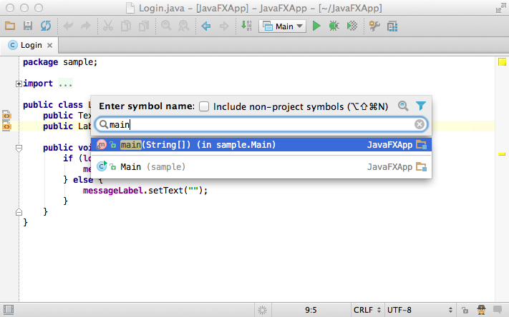

### **7. Select in**

And finally if you need to open the file in a particular tool window (or Finder/Explorer) you can do it via Select In action by pressing Alt +F1.

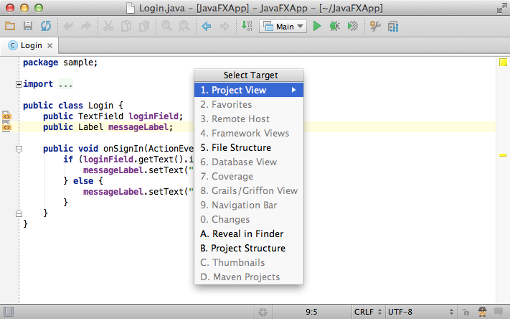

### **8. Other notable features**

* Navigate to line number via Ctrl + G (Cmd + G for Mac)
* Related files via Gutter
* Navigate to declaration via Ctrl + B (Cmd + B for Mac)
* Navigate to super via Ctrl + U (Cmd + U for Mac)
* Navigate to implementations via Ctrl + Alt + B (Alt + Cmd + B for Mac)
* Navigate to the last edit location via Shift + Ctrl + Backspace (Shift + Cmd + Backspace for Mac)
* Navigate to the next error or warning via F2
* Navigate to a related unit test via Shift + Ctrl + T (Shift + Cmd + T for Mac)

## [Quick Popups](https://confluence.jetbrains.com/display/IntelliJIDEA/Quick+Popups)

|  |
| --- |
| Quick popups are helpful for checking additional information related to the symbol at the caret. Here is a list of popups you should know if you want to be more productive. |

### **1. Parameter info**

The information on parameters required for a particular method is available via Ctrl + P (Cmd+P) shortcut. The popup shows the matched overloaded method, highlighting the current parameter.

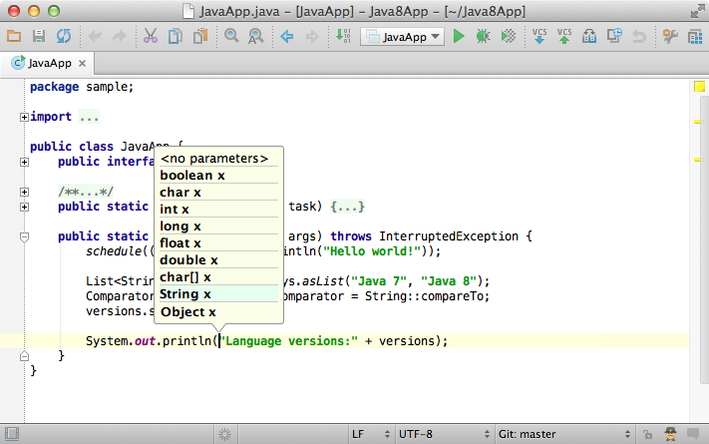

### **2. Quick Definition**

If you want to quickly look at the implementation of a symbol at the caret, you can call the Quick Definition by pressing  
Shift + Ctrl + I (Shift + Cmd + I).

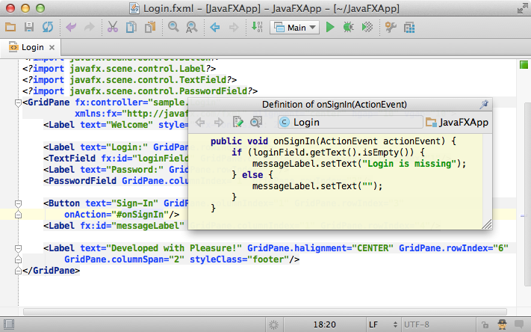

### **3. Documentation**

The documentation popup is one of the most used editor features. To see the documentation, just press Ctrl + Q (Ctrl + J for Mac).

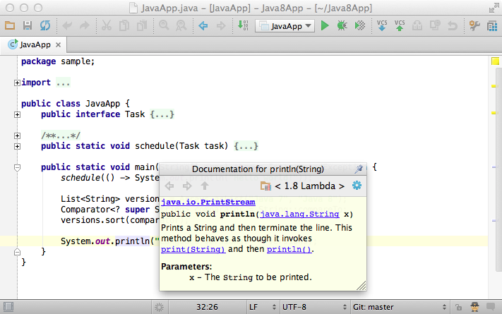

### **4. Pin popups**

If you want to keep the documentation open, click the Pin button in the top right corner. It will show the documentation for the current symbol.

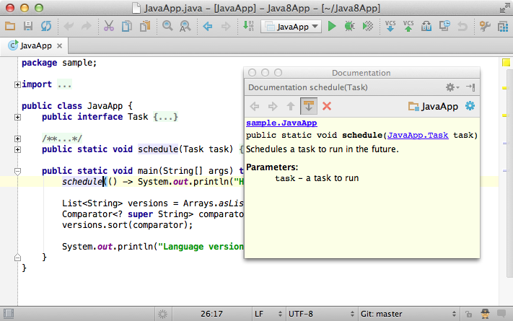

### **5. Dock popup**

If you don’t like float popup windows, you can dock them as a tool window by using the button in the top right-hand corner.

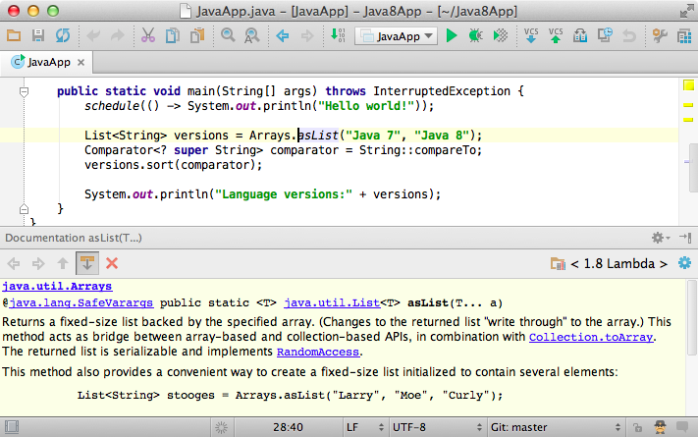

### **6. Popups in other components**

It is well-known that Quick popups are available for symbols in the editor. However, they are also available for items in any other list, via the same shortcuts:

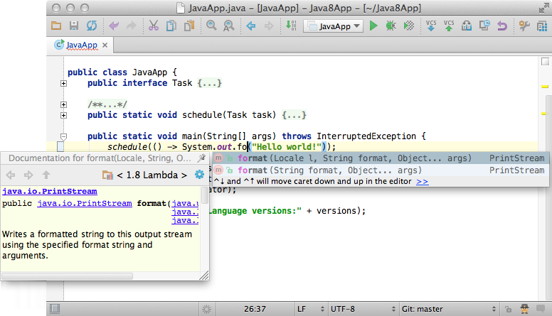

You can use quick popups even if you browse the elements from the Navigation bar via Alt + Home (Alt + ↖ for Mac).

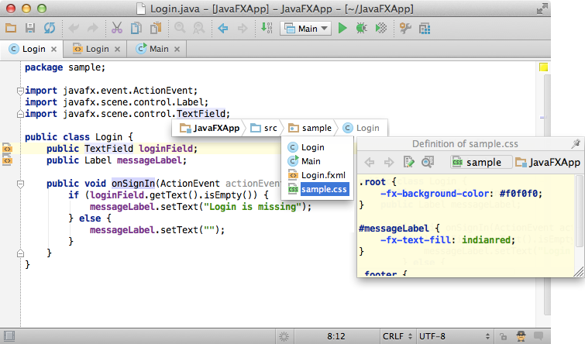

### **7. Show usages**

Show usages is a very simple but powerful feature. Just press Alt + Ctrl + F7 (Alt + Cmd + F7 for Mac) and get a list of usages for any symbol at the caret:

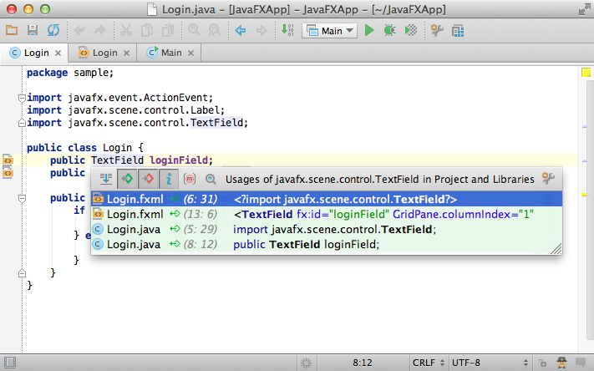

## [Refactoring Basics](https://confluence.jetbrains.com/display/IntelliJIDEA/Refactoring+Basics)

|  |
| --- |
| IntelliJ IDEA offers a comprehensive set of automated code refactorings that lead to significant productivity gains when used right. This tutorial will teach you how to do that, starting from the basic topics. |

### **1. Selection**

First of all, don't bother selecting anything before you apply a refactoring. IntelliJ IDEA is smart enough to figure out what statement you’re going to refactor, and only asks for confirmation if there are several possible choices.

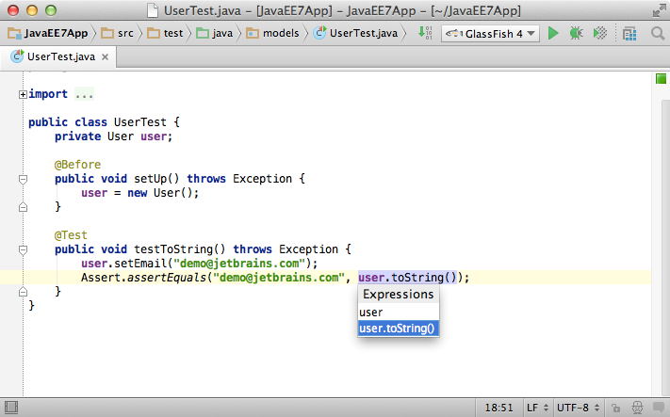

### **2. Undo**

Another important thing to know is that IntelliJ IDEA lets you undo everything, and that includes refactorings, no matter how complex code transformations they cause. Just press Ctrl + Z (Cmd + Z for Mac), and you're back to where you were before inadvertently scrambling a few thousands lines of code.

### **3. Mnemonics**

IntelliJ IDEA encourages you to use the keyboard instead of the mouse. It's proven to be faster and in the end will make you more productive at writing and transforming your code.

One thing that helps you easily use the keyboard to work with dialog boxes and popup windows is mnemonics---shortcut keys that are automatically assigned to each of the dialog elements. After you open a dialog, press and hold Alt to let IntelliJ IDEA highlight all available mnemonics. Then you can use them by pressing the highlighted key while holding Alt to access the elements you need.

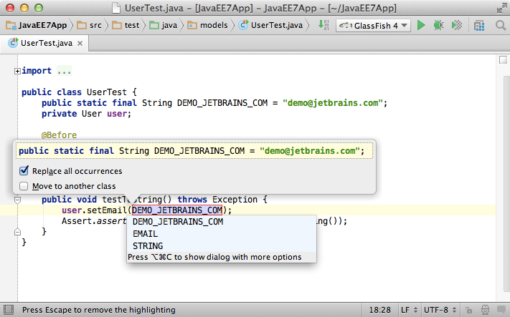

### **4. String fragments**

A real time saver is the ability to extract a part of a string expression with the help of the Extract... refactorings. Just select a string fragment and apply a refactoring to replace all of the selected fragment usages with the introduced constant or variable.

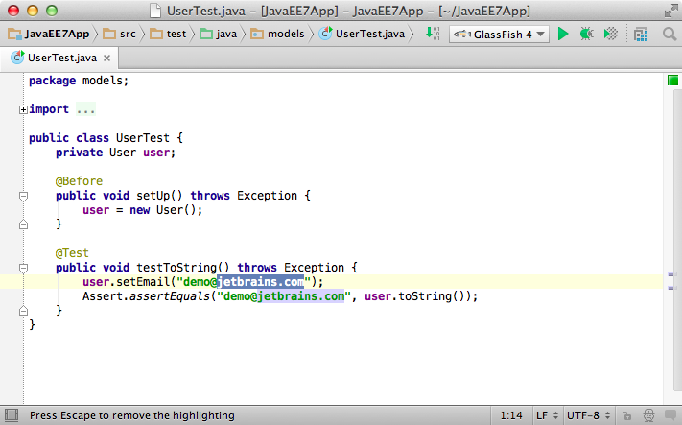

### **5. Change variable type**

Note that you can select a variable type when using the Extract variable refactoring. Press Shift+Tab when editing the variable name, and IntelliJ IDEA will offer you to select the variable type (e.g., you can tell it use the interface instead of implementation, or vice versa).

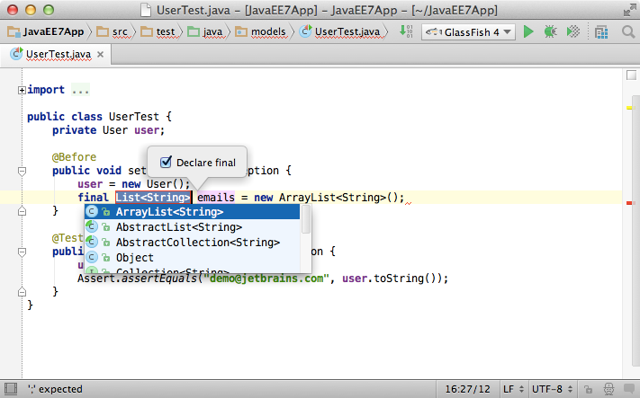

### **6. Invert boolean**

One basic but very helpful refactoring is the Invert Boolean, which inverts the semantics along with the data flow dependent expressions for any Boolean variable, parameter, field or method.

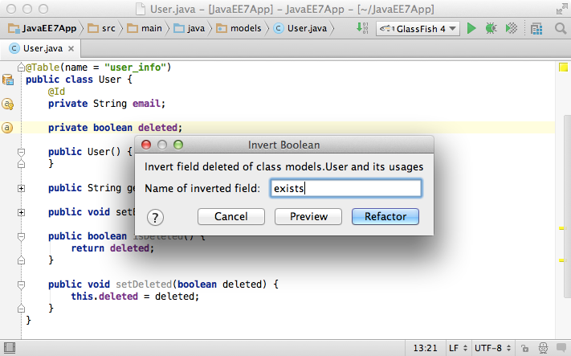

### **7. Type migration**

The Type Migration refactoring, as its name suggests, lets you automatically change the type for any class member, along with the dataflow-dependent type entries such as method return types, local variables, parameters, etc.

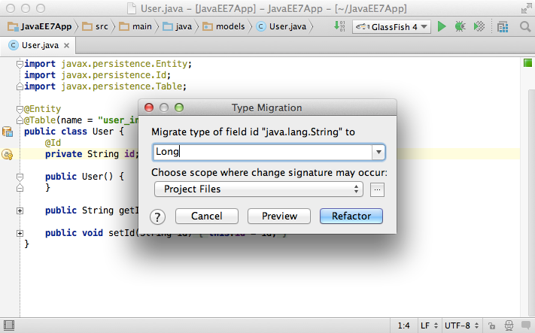

### **8. Essential refactoring shortcuts**

* Rename: Shift + F6
* Copy a class or file: F5
* Move a class or file: F6
* Extract a constant: Alt + Ctrl + C (Alt + Cmd + C for Mac)
* Extract a variable: Alt + Ctrl + V (Alt + Cmd + V for Mac)
* Extract a method: Alt + Ctrl + M (Alt + Cmd + M for Mac)
* Extract a field: Alt + Ctrl + F (Alt+ Cmd + F for Mac)
* Extract a parameter: Alt + Ctrl+ P (Alt+ Cmd + P for Mac)
* Inline a class or method: Alt + Ctrl + N (Alt + Cmd + N for Mac)
* Change signature: Ctrl + F6 (Cmd + F6 for Mac)

### **9. Other useful refactorings**

* Pull members up/down
* Extract a super class
* Extract an interface
* Convert an anonymous class to an inner class

### **10. Refactor this**

If you cannot recall the shortcut for a particular refactoring, or you're just not sure what to do next, simply use 'Refactor this action' by pressing Ctrl + Shift + Alt + T (Cmd + Shift + Alt + T). You will see the list of refactorings available in the current context.

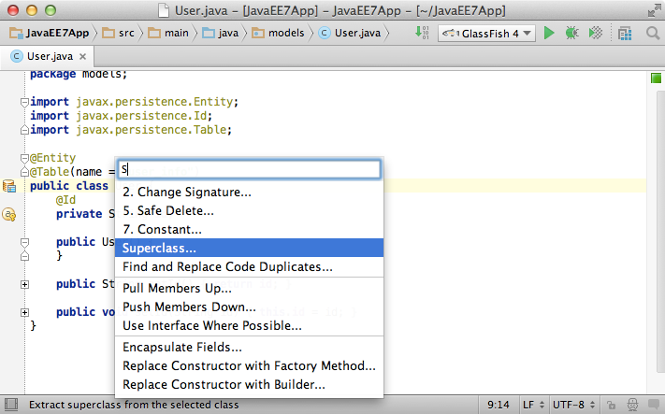

This is it for the refactoring basics. See the following tutorials for more advanced topics.

## [Folding](https://confluence.jetbrains.com/display/IntelliJIDEA/Folding)

|  |
| --- |
| Folding helps you keep your code neat and readable, by automatically collapsing the boilerplate or by replacing it with more relevant statements. |

You can see the original code behind the folded regions by placing the caret on it, or by moving the mouse over the collapsed pieces of code. Additionally you can always expand or collapse the folded blocks at the caret by calling the Toggle folding action via the shortcut  
Ctrl + . (Cmd + . for Mac).

### **1. Generics**

A very basic example of code folding is when the editor replaces parameter types in generics with the diamond operator added in Java 7. The code itself remains the same but it looks shorter and clearer.



### **2. Anonymous classes**

Another sample of code folding is when anonymous classes definition is replaced with the lambda notation added in Java 8. The lambda notation makes the code much shorter.



When you move the mouse over this or any other folded piece of code, you can still see the original code.

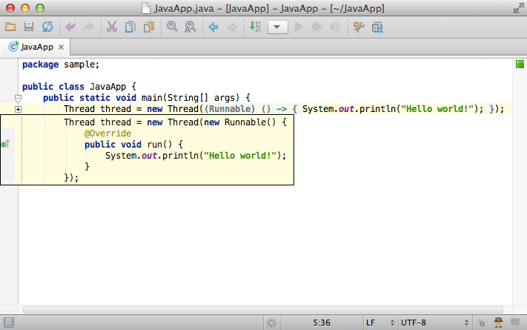

### **3. Folding settings**

You can always change the default behavior of code folding for particular statements via Settings → Editor → Code Folding.

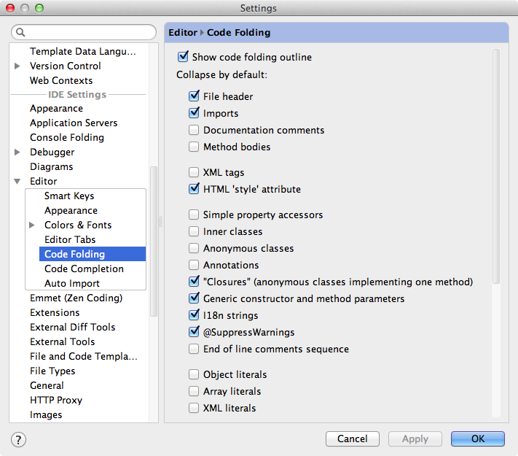

### **4. Other useful actions**

* Expand All via Shift + Ctrl + + (Shift + Cmd + + for Mac) automatically expands all collapsed blocks in the opened file.

## [Find Usages](https://confluence.jetbrains.com/display/IntelliJIDEA/Find+Usages)

|  |
| --- |
| Find usages helps you quickly find all pieces of code referencing a symbol at the caret, no matter if the symbol is a class, method, field, parameter, or another statement. |

### **1. Find usages**

Just press Alt + F7 and get a list of references grouped by type of usage, module and file. This feature is fast and gets you the first results almost immediately. More results appear as the IDE finds them.

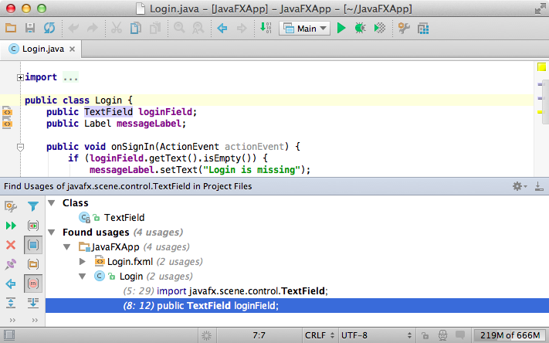

By default the results are not grouped by usage type, but you can enable this by pressing Ctrl + Alt + T or by clicking the corresponding button on the sidebar.

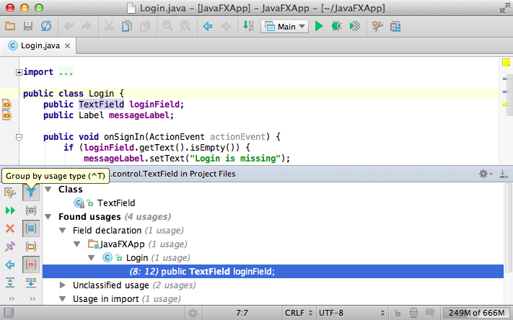

### **2. Options**

If you want to set custom options for the Find Usages algorithm, you can use Shift + Alt + Ctrl + F7 (Shift + Alt + Cmd + F7 for Mac) or click the first button on the right panel with search results.

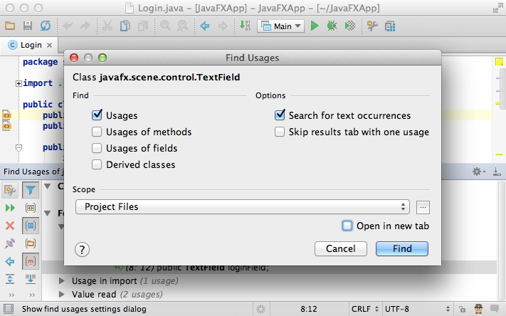

### **3. Open in a new tab**

If you want to keep the results of previous searches, tell the IDE to open new results in a new tab by checking the Open in new tab option.

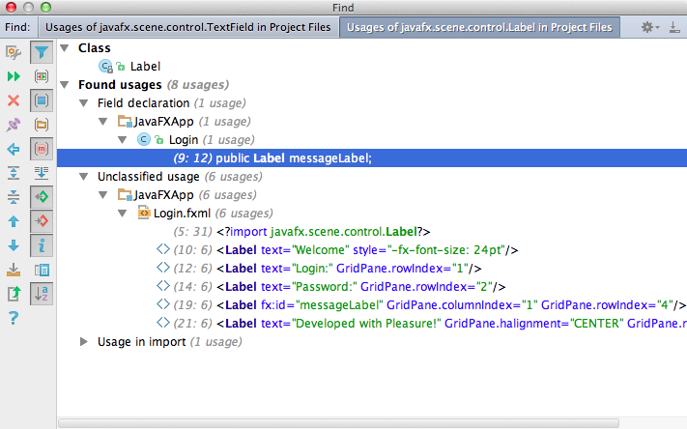

### **4. Quick popup**

If you want to see the results quickly without leaving the editor, simply press Alt + Ctrl + F7 (Alt + Cmd + F7 for Mac).



### **5. Highlight usages, return and throw statements**

By default, IntelliJ IDEA highlights the usages of a symbol, return or throw statement at the caret within the opened file in the editor.

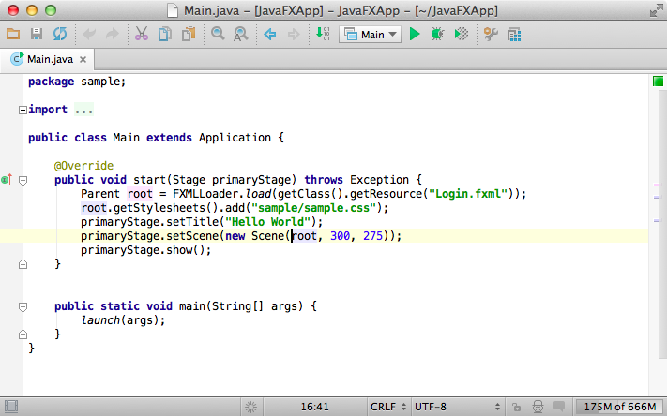

However, many developers prefer disabling this feature by deselecting  
Settings → Editor → Highlight usages of element at the caret and calling it via Shift + Ctrl + F7 (Shift + Cmd + F7 for Mac) instead, only when you need it. This way you can highlight more than one symbol if you want, and to remove the highlighting by simply pressing Esc.

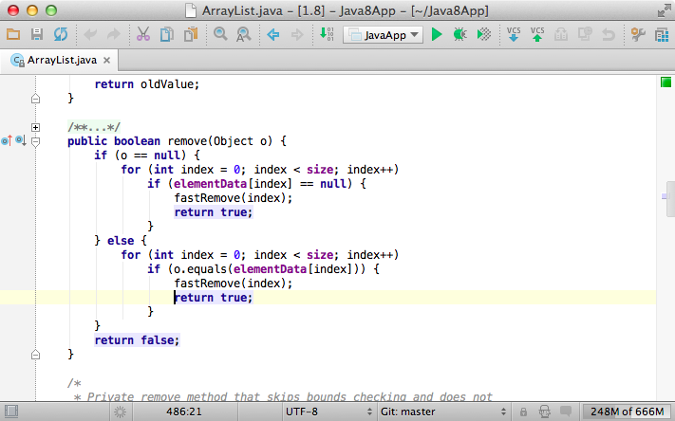

### **6. Highlight implemented and overridden methods**

Another useful aspect of highlighting usages in IntelliJ IDEA is that you can easily find the methods that are overridden or implemented for a particular class or interface. Just put the caret at the implements or extends statement and press Shift + Ctrl + F7 (Shift + Cmd + F7for Mac). If there are multiple classes or interfaces, you will be asked whose methods to highlight.

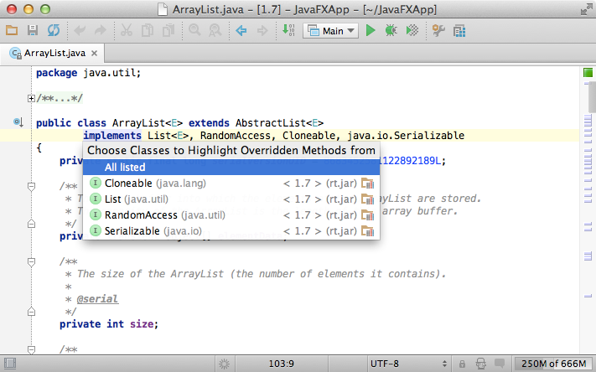

## [Inspections](https://confluence.jetbrains.com/display/IntelliJIDEA/Inspections)

|  |
| --- |
| Inspections are built-in static code analysis tools that help you find probable bugs, locate dead code, detect performance issues and improve the overall code structure. |

### **1. On-the-fly code analysis**

Most of the inspections run on-the-fly and display warnings or errors in the editor immediately as you type.

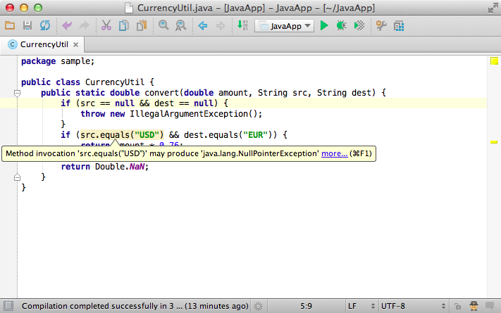

Inspections that are too complex to be run on on-the-fly are available when you perform code analysis for the entire project via Analyze →Inspect Code menu, or when you run certain inspection by its name via Analyze → Run Inspection by Name.

### **2. Navigate to the next/previous problem**

Editor lets you quickly navigate between the highlighted problems via keyboard shortcuts. Press F2 to go to the next problem and Shift+F2 to the previous one. You can configure severity of problems through which the F2 key navigates in the Settings → Editor and tell it, for example, to always jump to the most serious issue in a file.

### **3. Run project-wide inspections**

To get complete report with the inspection results for an entire project, use the Analyze → Inspect Code command.

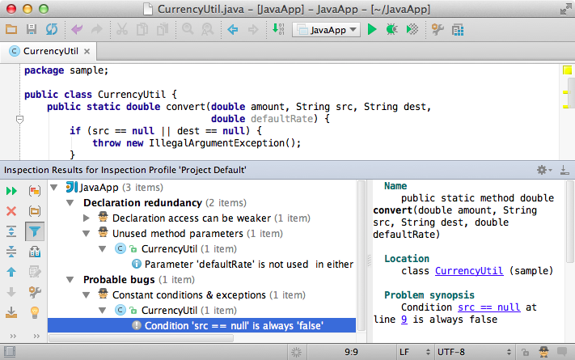

### **4. Quick-fixes**

Most inspections not only tell you where a problem is, but provide quick-fixes to deal with them right away. Just press Alt + Enter and choose a quick-fix.



### **5. Suppress warnings**

When you don’t want warnings from this or that inspection for a specific statement or method, you can simply suppress them by pressing the right arrow on a quick-fix. Sometimes it may be a better solution than disabling the inspection for an entire project.



### **6. Run a single inspection**

To run a single inspection by its name just press Shift + Alt + Ctrl + I (Shift + Alt + Cmd + I for Mac) shortcut or use Analyze →Run Inspection by Name.



### **7. Highlighting level and power save mode**

Another useful thing is the Hektor icon located on the status bar. It helps you switch highlighting levels: from none to syntax and inspections. At syntax level you don't get any warnings except when code can't be compiled.

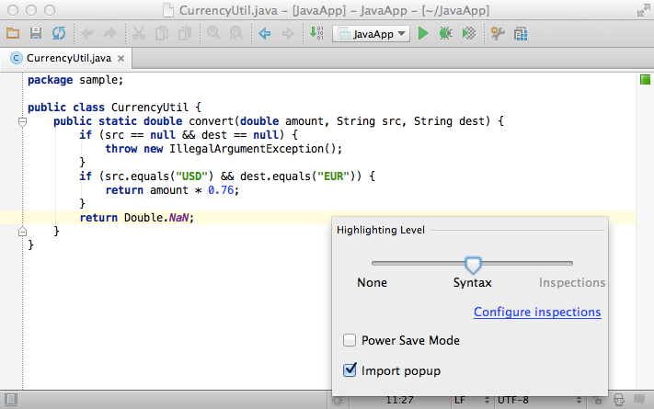

The Hektor icon also lets you activate power save mode that helps conserve battery power by disabling highlighting and auto-popups.

### **8. Inspection profiles**

And finally you can change the list of inspections enabled for a project by managing the inspection profiles via Settings → Inspections. If you want to share your inspection profile with your team, enable Share profile checkbox and submit inspections project files into VCS.

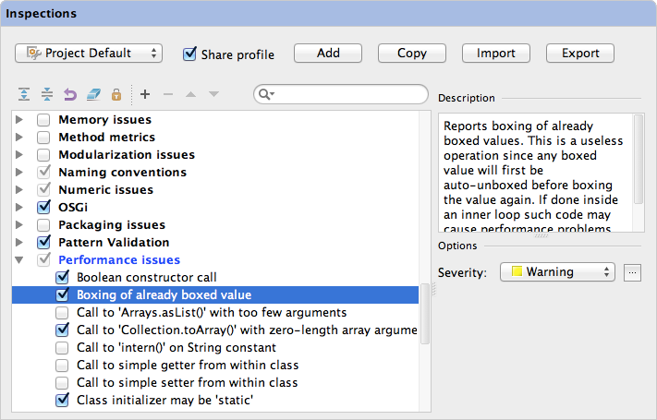

## [Code Style and Formatting](https://confluence.jetbrains.com/display/IntelliJIDEA/Code+Style+and+Formatting)

|  |
| --- |
| Code style defines how code looks in terms of indents, spacing, wrapping, blank lines treatment, statements order, etc. |

### **1. Reformat code**

IntelliJ IDEA automatically applies code style you've configured as you edit, and in most cases you don’t need to call Reformat Code action explicitly. However, you can do so anytime either for current file, selected piece of code, or even an entire directory by simply pressing Alt +Ctrl + L (Alt + Cmd + L for Mac.)

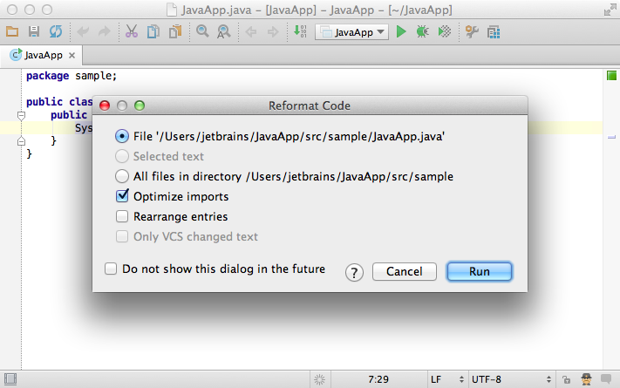

When you want to apply Reformat Code to an entire directory, use the same shortcut in the Project Tool Window.

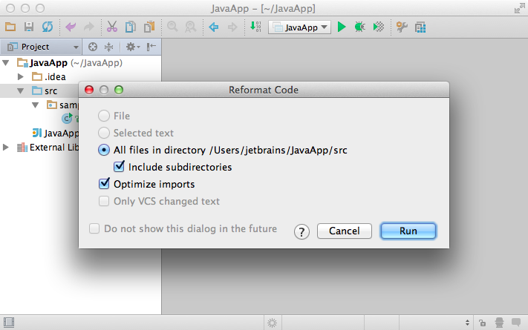

### **2. Auto-indent lines**

Another useful action is Auto-Indent Lines, which helps you to fix line indentation. This action sometimes is a better option thanReformat Code, because it does not require you to select anything. Just press Alt + Ctrl + I (Alt + Cmd + I for Mac), and it will quickly fix indents for the current line.



### **3. Settings**

IntelliJ IDEA lets you configure code style settings for each of the supported languages either at project or IDE level via Settings →Code Style.

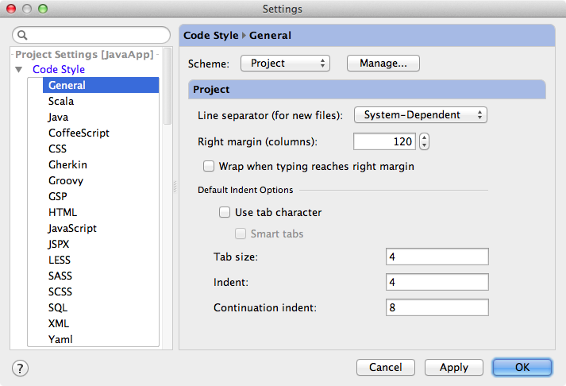

When you choose Project scheme in settings, you can share your code style with other team members via version control.

### **4. Tab character**

Last, but not least of the settings worth your attention is Use tab character. By default this setting is off and IntelliJ IDEA uses regular spaces for indents instead of tabs. If you have files with lots of indents, you may want to optimize their size by selecting this option.

## [Intentions](https://confluence.jetbrains.com/display/IntelliJIDEA/Intentions)

|  |
| --- |
| While inspections provide quick-fixes for code that has potential problems, intentions help you apply automatic changes to code that is correct. |

To get a list of intentions applicable to the code at the caret, just press Alt + Enter.

### **1. Optimize statements and manage braces**

Since the IDE is aware of the data flow in your code, it can help you optimize Boolean conditions and transform if/else statements:



With intentions you can, for example, automatically add and remove braces for your statements:



### **2. String concatenation**

If you have String concatenation, the IDE can help you replace it with a String.format expression or a StringBuilder pattern.



### **3. Switch between loop declaration styles**

With intentions you can also switch between loop declaration styles or even reverse its direction.



### **4. Math expressions**

If you have a complicated math expression, the IDE will offer you to simplify an expression or possibly clarify it with parentheses.



### **5. Disable intention**

If you don’t want to see a certain intention, you can disable it by selecting the right arrow on the intention.

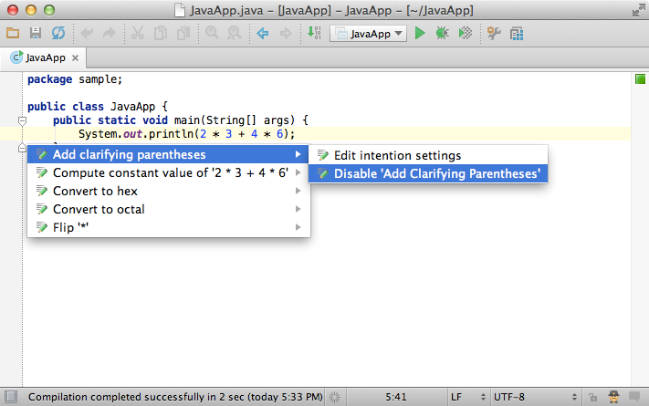

### **6. Settings**

The complete list of intentions (several hundred in total), grouped by language and framework, can be found in Settings → Intentions. Here you can enable/disable whole groups of intentions:

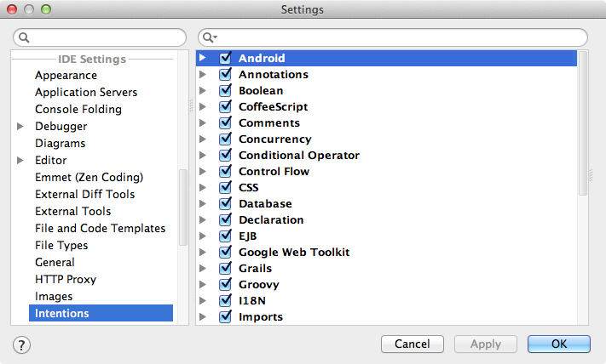

## [Version Control Basics](https://confluence.jetbrains.com/display/IntelliJIDEA/Version+Control+Basics)

|  |
| --- |
| One of the nicest things about IntelliJ IDEA is its seamless integration with major version controls like **Git**, **GitHub**, **Subversion**,**Mercurial**, **Perforce**, **TFS**, **CVS**, **Visual SourceSafe** and **Rational ClearCase**. |

### **1. Check out a project from version control**

To import a project from version control click the Check out from Version Control button on the Welcome screen, or use the same command from the VCS on main menu.

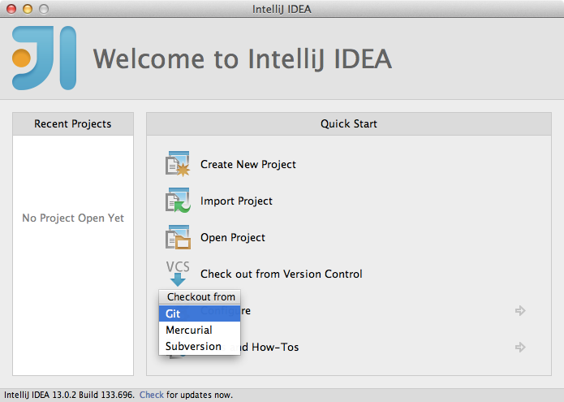

If the project has Maven or Gradle build files, IntelliJ IDEA will offer to use them for configuration.

### **2. Version control settings**

Project version control settings are accessed via Settings → Version Control. You can associate any of the project folders with a repository root. These associations can be removed at any time, or you can even opt to disable the version control integration entirely.

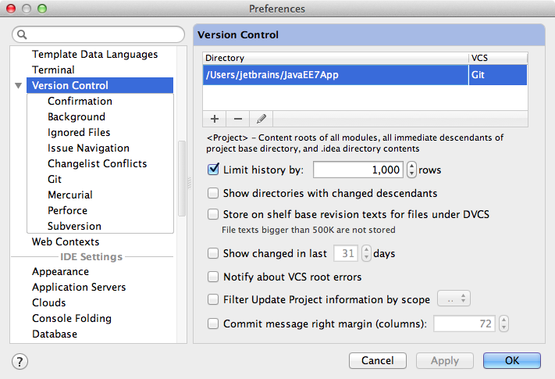

IntelliJ IDEA can handle multiple VCS repositories assigned to different folders of the project hierarchy and perform all VCS operations on them uniformly.

### **3. Changes tool window and changelists**

After version control is enabled for a project, you can see and manage your local changes via the Changes tool window. To quickly access the tool window use the Alt + 9 (Cmd+9 for Mac) shortcut.

To make working with changes easier, all changes are organized into changelists that can be created, removed, and made active.

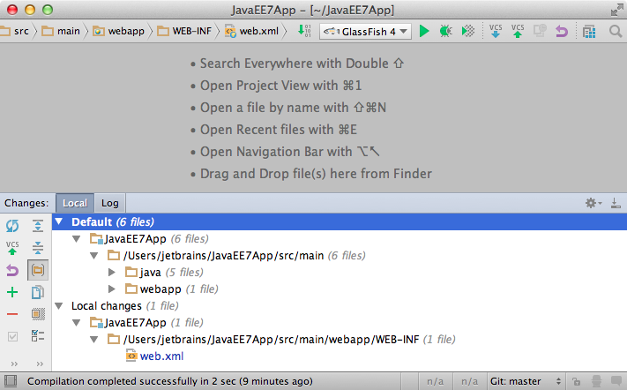

### **4. VCS operations quick list**

When you need to perform a VCS operation from on a currently selected file, directory, or even on the entire project, use the VCS operationsquick list via the Alt + Back Quote (Ctrl + V for Mac) shortcut.

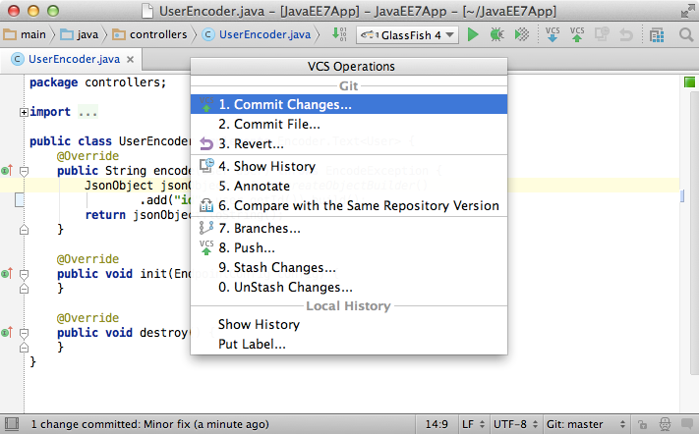

### **5. Show history**

The changes history is available for a set of files or directories via the VCS operations quick list, or in the main menu VCS → <Version control name> → Show History, or the context menu <Version control name> → Show History.

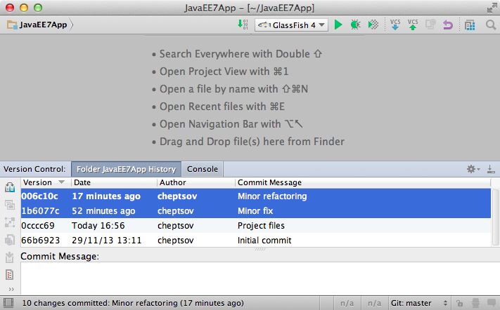

To see all changes for a specific piece of code, use the Show History for Selection action.

### **6. Annotation**

Annotations are available from both the quick list, the main and context menus, and they allow you to see who and when changed this or that line of code.

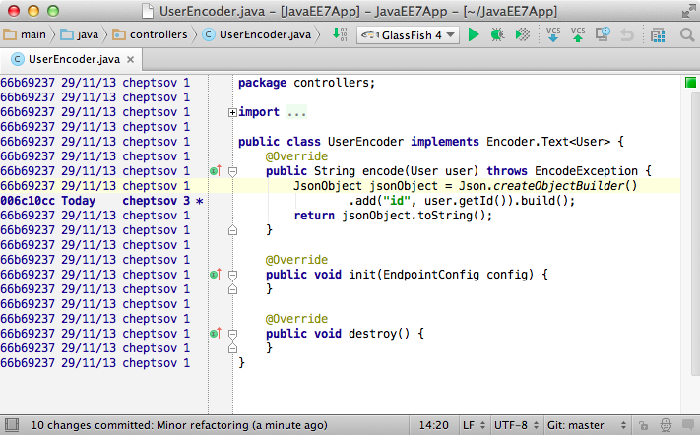

When you click annotation, you will see the detailed information about corresponding commit.

### **7. Useful shortcuts**

* Commit current changelist Ctrl + K (Cmd + K for Mac)
* Update the project Ctrl + T (Cmd + T for Mac)
* Mark selected files and folders as added Ctrl + Alt + A (Alt + Cmd + A for Mac)
* Mark selected files and folders as changed (checked out) via Ctrl + Alt + E (Alt + Cmd + E for Mac)
* Show diff (available in the Changes tool window) via Ctrl + D (Cmd + D for Mac)
* Move changes to another change list (available in the Changes tool window) via F6
* Push commits to remote repositories via Ctrl + Shift + K (Cmd + Shift + K for Mac)

### **8. Commit options**

When committing changes, IntelliJ IDEA lets perform a variety of operations: change the file set to commit to, join the changes with the previous commit by using the Amend commit option, reformat the changed code, optimize imports, ensure that there are no inspection warnings, update the copyright information, or even upload the changes to a remote FTP server.

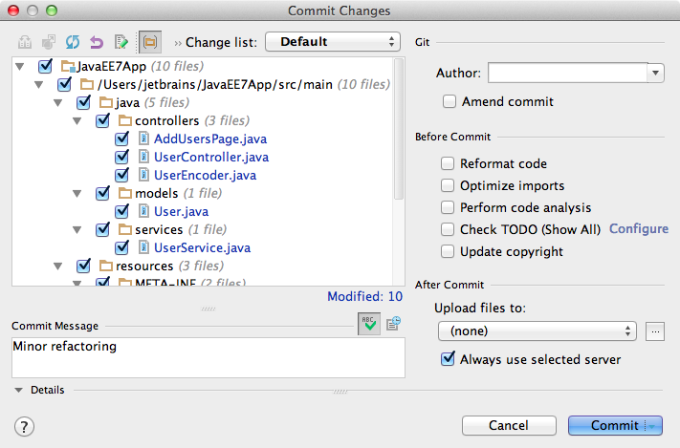

### **9. Ignored files**

To configure the ignored files go to Settings → Version Control, or use the corresponding button in the Changes tool window.

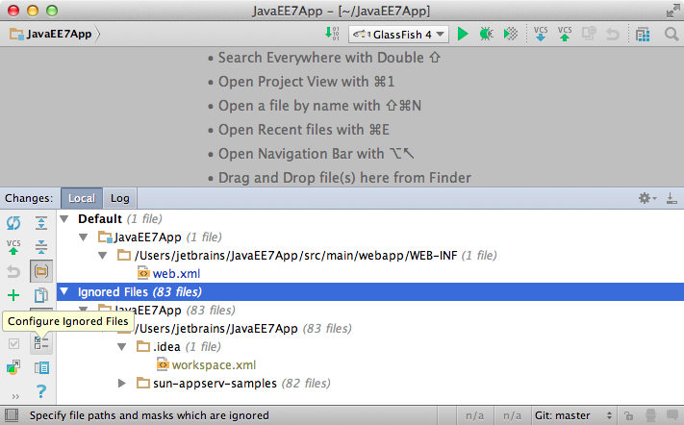

The actual list of ignored files can be displayed in the Changes tool window next to the changelists by clicking the corresponding button.

### **10. Branches**

With IntelliJ IDEA you can easily create, switch, merge, compare and delete branches (Git and Mercurial only). To see a list of existing branches or create a new one, use either the Branches from the main or context menu, or the VCS operations quick list, or the widget on the right side of the status bar.

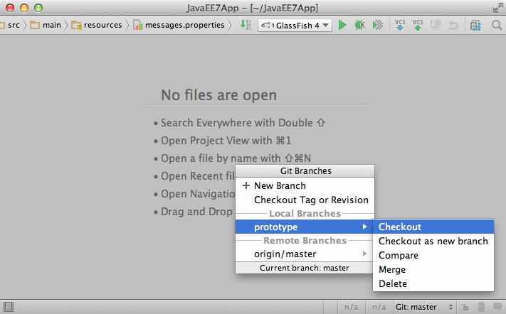

For multiple repositories IntelliJ IDEA performs all VCS operations on all branches simultaneously, so you don't need to switch between them manually.

### **11. Shelves, stashes, and patches**

The Shelves and Stashes help you when you need to put away some of local changes without committing them to repository, then switch to repository version of files, and then come back to your changes later. They differ slightly in that the Shelves are handled by IntelliJ IDEA itself and are stored in local file system, while stashes are kept in a VCS repository. The Patches allow you to save a set of changes to a file that can be transferred via email or file sharing and then applied to the code. It’s helpful for when you're working remotely without having a constant connection to your VCS repository and still need to contribute.

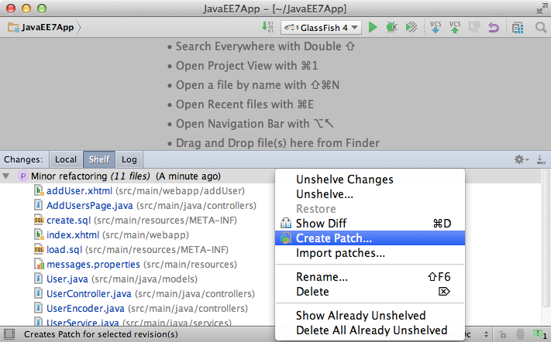

### **12. Log**

To see the entire list of commits in a repository, sorted and filtered by branch, user, date, folder, or even a phrase in description, use the Logtab in the Changes tool window. This is the easiest way to find a particular commit, or to just browse through the history.

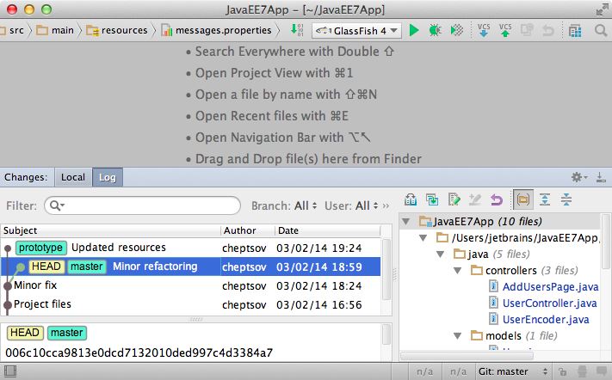

This is it for the VCS basics. See the following tutorials for more advanced topics.

## [Debugger](https://confluence.jetbrains.com/display/IntelliJIDEA/Debugger)

### **1. Run debug**

After you have configured a run configuration for your project, you can run it in debug mode by pressing Shift + F9.

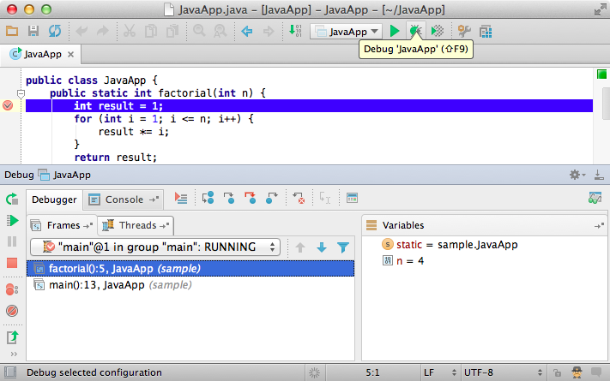

In Debug tool window you can see the list of frames and threads with their states, variables and watches. When you select a frame, you see the variables corresponding to the selected frame.

### **2. Useful debugger shortcuts**

* Toggle breakpoint via Ctrl + F8 (Cmd + F8 for Mac)
* Resume program via F9
* Step over via F8
* Step into via F7
* Stop via Ctrl + F2 (Cmd + F2)
* View breakpoint details/all breakpoints via Shift + Ctrl + F8 (Shift + Ctrl + F8)
* Debug code at caret via Shift + Ctrl + F9 (e.g if you stay within the main method)

### **3. Smart step into**

Sometimes it happens that you stay at a line and want to step into a particular method but not the first one which will be invoked. In this case you can use Smart step into by pressing Shift + F7 (Cmd + F7 for Mac) to choose a particular method. This is a great time-saver.

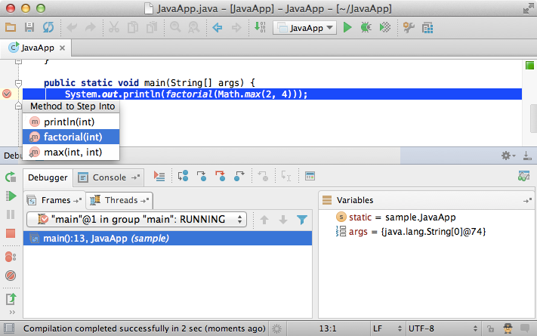

### **4. Drop frame**

In case you want to “go back in time” while debugging you can do it via Drop Frame action. This is a great help if you mistakenly stepped too far. This will not revert the global state of your application but at least will get you back by stack of frames.

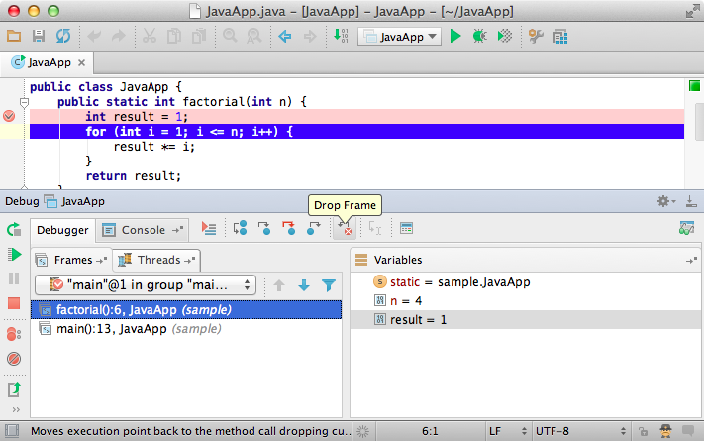

### **5. Run to cursor**

Sometimes you need to resume the program and stop at another line of code, without adding another break point. Easy: just press  
Alt + F9.

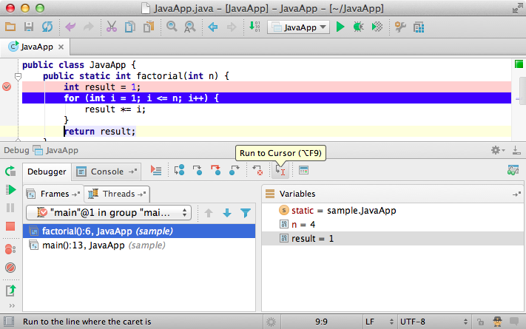

### **6. Mark instance**

If you want a particular instance to be always recognized while debugging, you can mark it with a colored label via F11 or the context menu in Variables and Watches tabs.

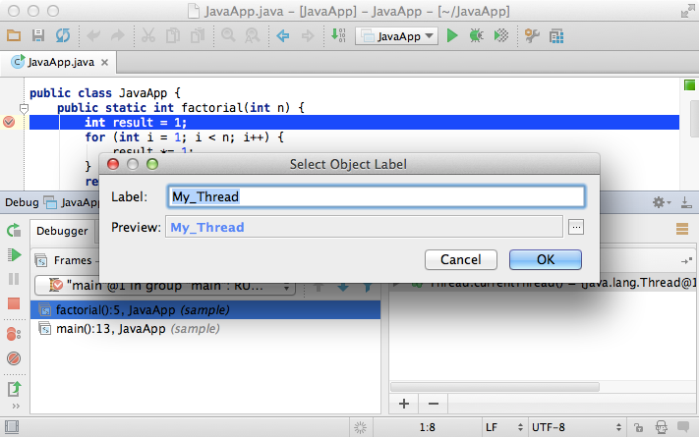

The next time this instance appears in Watches, Variables or Evaluate expression, you will see the label.

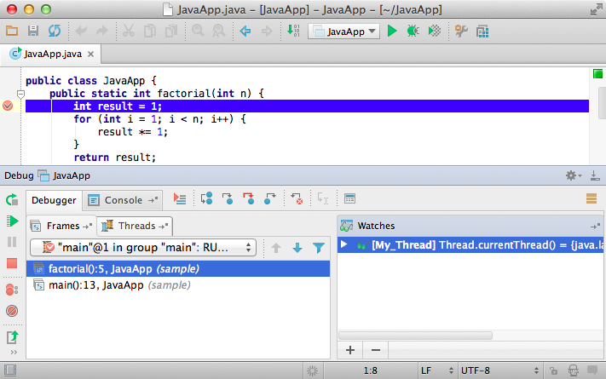

### **7. Evaluate expression**

While in debug mode you can evaluate any expression using thevery powerful Evaluate expression tool by pressing Alt + F8.

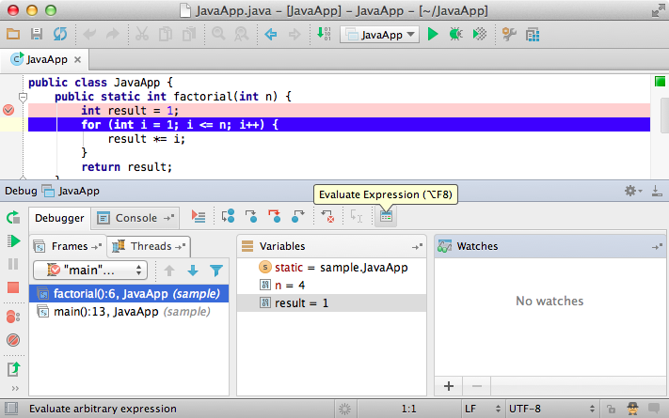

This tool provides code completion just as in the editor so it’s very easy to enter any expression.

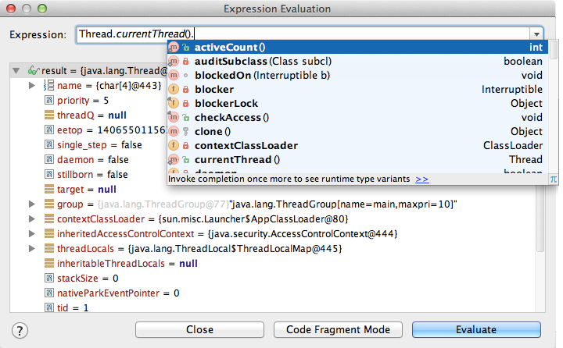

If you have any instances marked with labels, code completion will offer you its names so you can evaluate them.

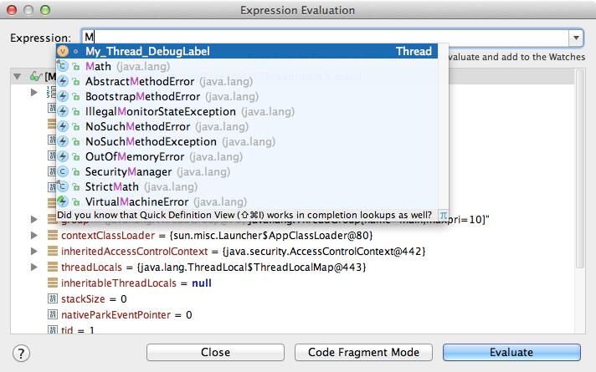

### **8. Breakpoint details and condition**

If you want to change a breakpoint's details, you can press Shift + Ctrl + F8 (Shift + Cmd + F8 for Mac). Here you can specify the breakpoint condition.

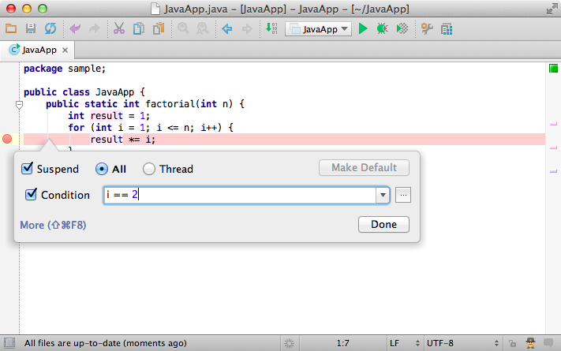

And if you have any instance marked with a label, you can use it in the condition expression as well.

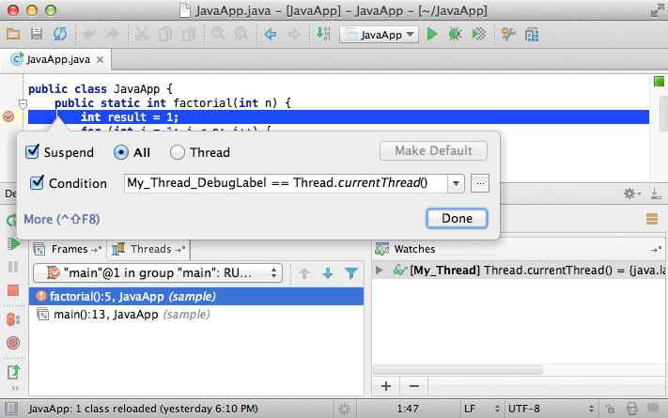

To see all breakpoints in the project (with more advanced settings), press Shift + Ctrl + F8 (Shift + Cmd + F8 for Mac) again.

### **9. Field breakpoints**

In addition to conditional breakpoints you can also use Field breakpoints. These breakpoints stop when a field is accessed for read or write. To create such a breakpoint, just click on the gutter while holding Alt.

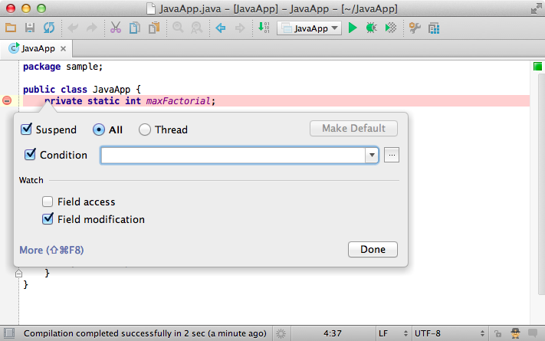

### **10. Action breakpoints**

Another action might be useful if you want to evaluate something at a particular line of code without actually making a stop. You can do that by using the Action breakpoint. To create one, just click on the gutter while holding Shift.

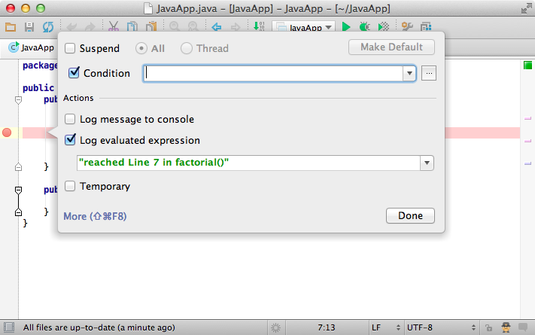

### **11. Temporary breakpoints**

To create a breakpoint which stops only once, click on the gutter while holding Shift + Alt.

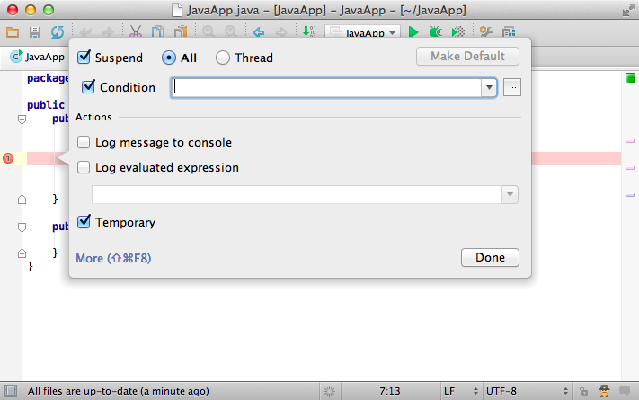

### **12. Disable breakpoints**

It's also useful to know that any breakpoint can be quickly disabled by clicking on the gutter while holding Alt.

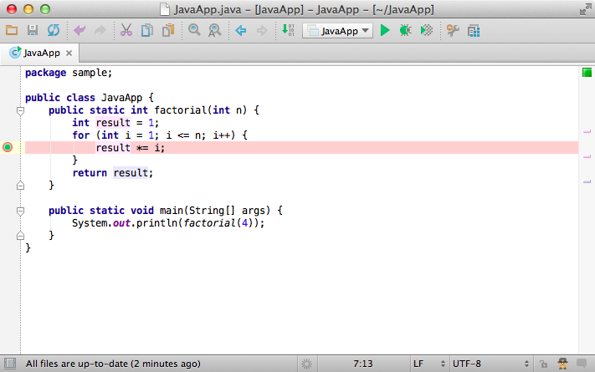

### **13. Reload changes and hot swapping**

Sometimes it happens that you need to insert minor changes in your code without shutting down the process. Since Java VM has such a feature as HotSwap, the IDE handles these cases automatically and offers you to reload the changed classes whenever you compile the changed classes while in debug mode.

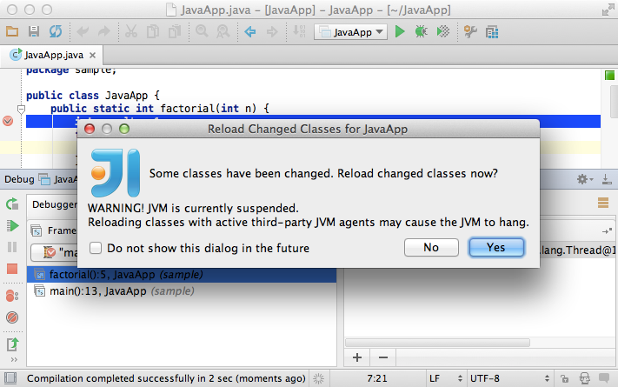

Keep in mind that Java VM’s HotSwap has a number of constraints and does not support reloading of static fields and methods.

### **14. Remote debug**

The final thing you definitely should know about debugging in IntelliJ IDEA is Remote debug. Remote debug means attaching debugger to a process which is already running on a specific port on your or any other’s host. This way you can attach the debugger to your application server which is running standalone.

To create a remote configuration, go to Edit configurations and add Remote run configuration. Make sure to specify the correct host and port before you run this configuration.

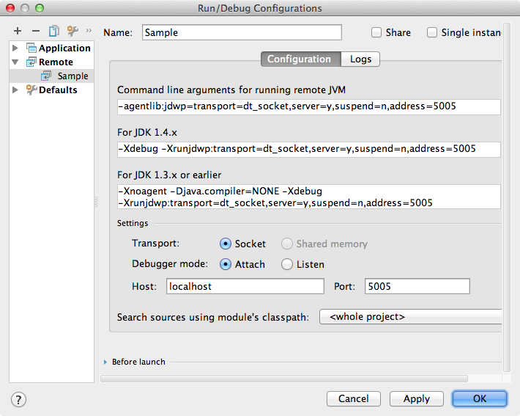

### **15. Settings**

If you want to change the default debugger settings, press Settings → Debugger.

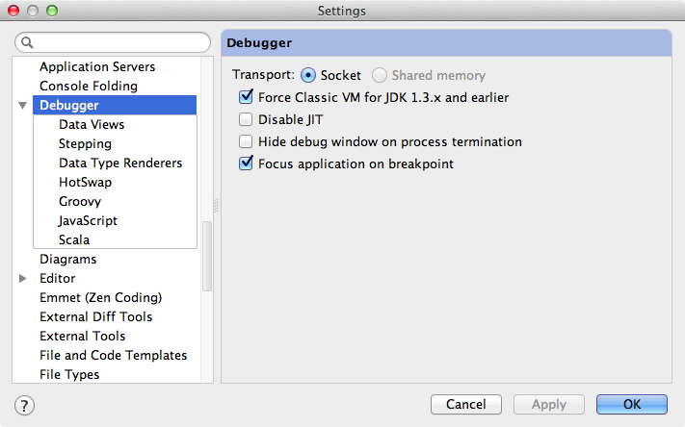

## [Keymap](https://confluence.jetbrains.com/display/IntelliJIDEA/Keymap)

|  |
| --- |
| You may have heard that IntelliJ IDEA is a keyboard-centric IDE. What it means, is that you can work with it without touching the mouse ever, which helps you stay focused and in the end, to be more productive. This is why it’s very important to know IntelliJ IDEA keymap, that is, what keys and key combinations are mapped to what actions. |

### **1. Settings**

IntelliJ IDEA comes with a set of keymaps that have been specially adapted for use with different operating systems, and to ease the transition from other IDE and editors. For example, if you are a long time user of Eclipse or NetBeans, or an avid Emacs fan, you can find the keymap that is right for you. To select a keymap that you want to use, go to Settings → Keymap. Any keymap you choose can further be tailored to your specific habits, that is you can add your own key combinations and modify existing ones.



### **2. Find action by shortcut**

If you are wondering what this or that key shortcut does, look it up as shown on the following picture.



The complete keymap reference is always available via Help → Default Keymap Reference, and on IntelliJ IDEA [website](http://www.jetbrains.com/idea/documentation/index.jsp).

### **3. Call action by name**

Whenever you need to perform some action, but don’t know what shortcut to use, press via Shift + Ctrl + A (Shift + Cmd + A for Mac) directly from the editor, and start typing what you are looking for.

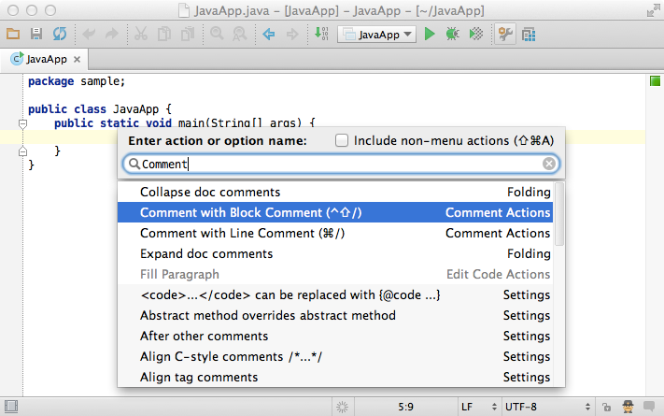

### **4. System shortcuts conflicts**

Sometimes if you’d chosen a keymap that is specific for your operating system, there may still be conflicts between shortcuts used in IntelliJ IDEA and your OS. To avoid these conflicts, simply make the following tweaks in your system settings.

### **5. Mac OS X**

Switch the F1 - F12 keys to the standard function keys behaviour, because they are all actively used them in IntelliJ IDEA.

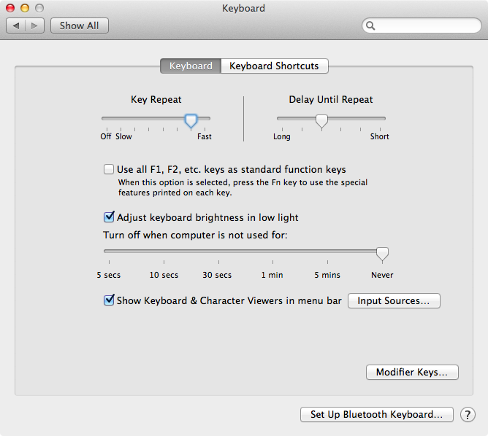

Disable Show Spotlight search field, because its shortcut is Ctrl + Space, a default code completion shortcut in IntelliJ IDEA.

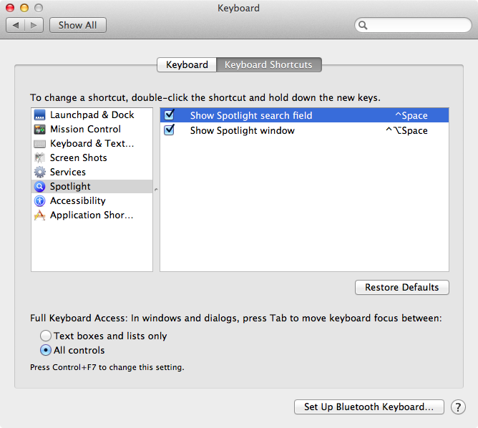

By default, the Mac OS X keymap is selected when you run IntelliJ IDEA for the first time on any Mac OS machine, but you can opt to the use of the Mac OS X 10.5+ keymap, which was specially designed for Mac OS X version 10.5 and later and is more friendly to users who are used to the Mac OS X system shortcuts.

### **6. Ubuntu**

Here’s a list of tweaks you need to make with default system key bindings so that they won’t interfere with IntelliJ IDEA actions (listed in brackets).

* Disable the Shade window action, assigned to Ctrl + Alt + S (Settings dialog)
* Change or disable the Lock Screen action, assigned to Ctrl + Alt + L (Reformat code)
* Change or disable the Launch terminal action, assigned to Ctrl + Alt + T (Surround with)
* Change or disable the Switch to workspace action, assigned to Сtrl + Alt + Arrows (Navigation)
* Disable the Move window action, assigned to Alt + F7 (Find usages)
* Change or disable the Resize window action, assigned to Alt + F8 (Evaluate expression)

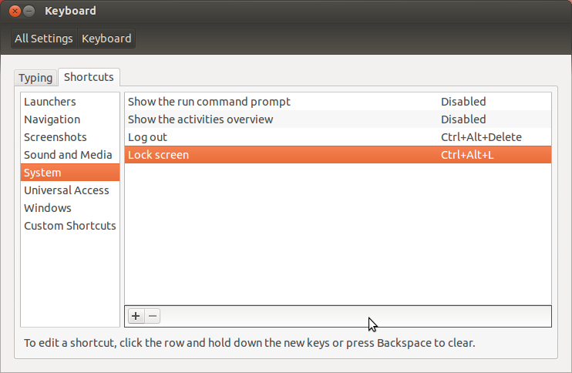

### **7. Vim**

And finally if you are a dedicated [Vim](http://vim.wikia.com/wiki/Vim_Tips_Wiki) fan, and cannot go on coding in a different editor, then you will happy to know that IntelliJ IDEA has Vim emulation plugin. To enable Vim keymap in IntelliJ IDEA you have to download and enable [IdeaVim plugin](http://plugins.jetbrains.com/plugin/?ruby&id=164) in Settings → Plugins.

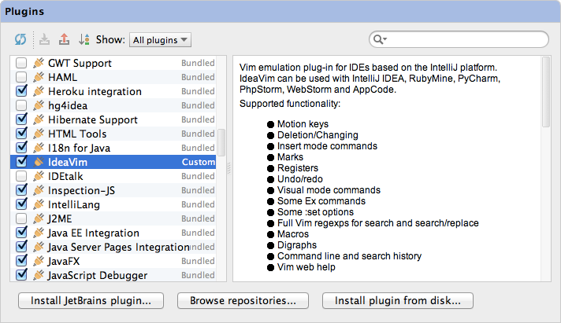

The plugin supports many Vim features including shortcuts, motion keys, many types of commands, registers, macros, modes and a [lot more](http://www.youtube.com/watch?v=UlREhZ-orlk).

|  |  |  |
| --- | --- | --- |
| [Previous](https://confluence.jetbrains.com/display/IntelliJIDEA/Debugger) | Debugger | [Top](https://confluence.jetbrains.com/display/IntelliJIDEA/Quick+Start) | Quick Start | [Next](https://confluence.jetbrains.com/display/IntelliJIDEA/Application+Servers) | Application Servers |

**Labels:**

None

窗体顶端

窗体底端

## [1 Comment](https://confluence.jetbrains.com/display/IntelliJIDEA/Keymap)

[comments.show.hide](https://confluence.jetbrains.com/display/IntelliJIDEA/Keymap)

1. 

Dec 12, 2014

#### Anonymous

This is helpful. Am I the only one who thinks using function keys on the Mac is way to difficult?

Using the OS-X 10.5+, at least I can run an app with ctrl-r and not shift F10, which equates to fancy finger work.

* + [Permalink](https://confluence.jetbrains.com/display/IntelliJIDEA/Keymap?focusedCommentId=57286963#comment-57286963)
  + [Reply](https://confluence.jetbrains.com/pages/replycomment.action?commentId=57286963&pageId=51958614)

## [Application Servers](https://confluence.jetbrains.com/display/IntelliJIDEA/Application+Servers)

|  |
| --- |
| **IntelliJ IDEA Ultimate** comes with out-of-the-box support for the most popular enterprise and open-source application servers including**GlassFish**, **WebLogic**, **JBoss EAP**, **Wildfly**, **WebSphere**, **Tomcat**, **TomEE**, **Jetty**, **Geronimo**, **Resin** and **Virgo**. |

### **1. Application servers**

To configure a server in the IDE, go to Settings → Application Servers and click the Add application server button. The IDE will automatically detect its version and offer you to select which libraries to add to the dependencies when the server is used in the project.

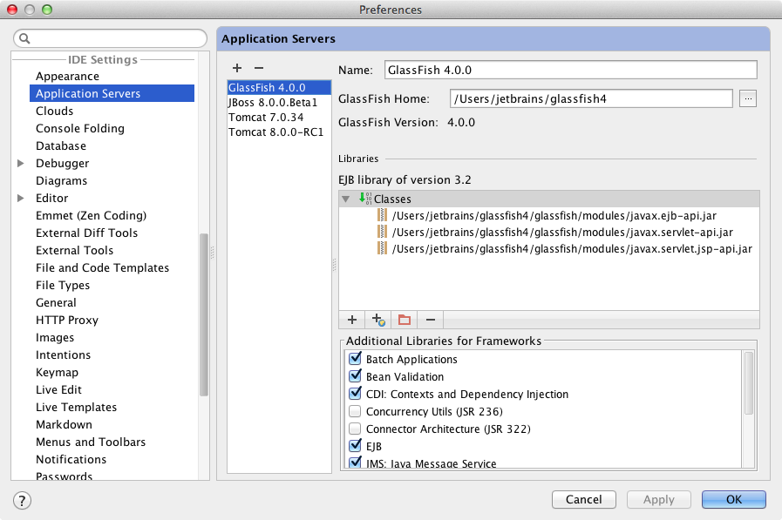

### **2. Web facet**

One important thing when working with an application server is the Web facet. This is where the IDE stores the web settings for each module of your project. These settings include the deployment descriptors and web resources roots, and are available in Project Structure →Modules and Project Structure → Facets.

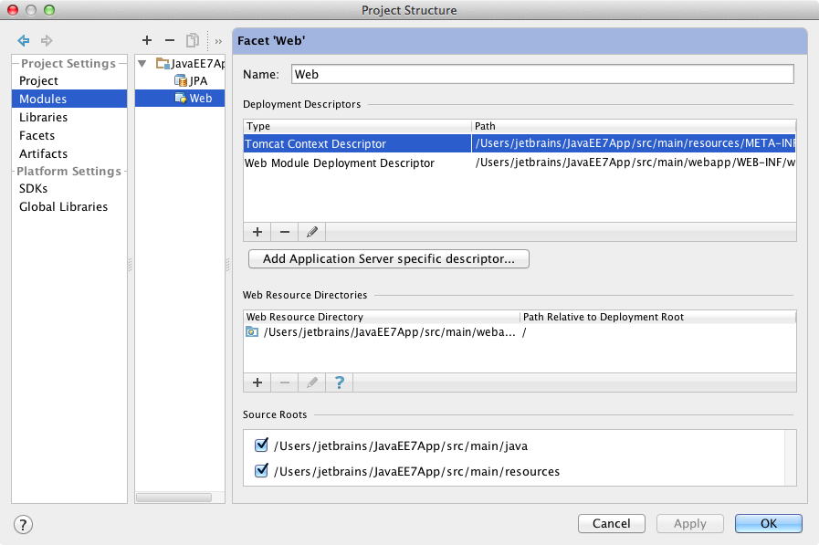

Usually you don’t need to configure the Web facet manually. The IDE automatically detects the descriptors and web resource roots and offers to configure it.

### **3. Artifacts**

An artifact is what the IDE deploys to a server when you run the application via Run configurations. Each artifact has its name, type, output directory, layout and type (Web Application: Archive, Web Application: Exploded, EJB Application: Archive, EJB Application: Exploded, etc). To configure the artifacts, go to Project Structure → Artifacts.

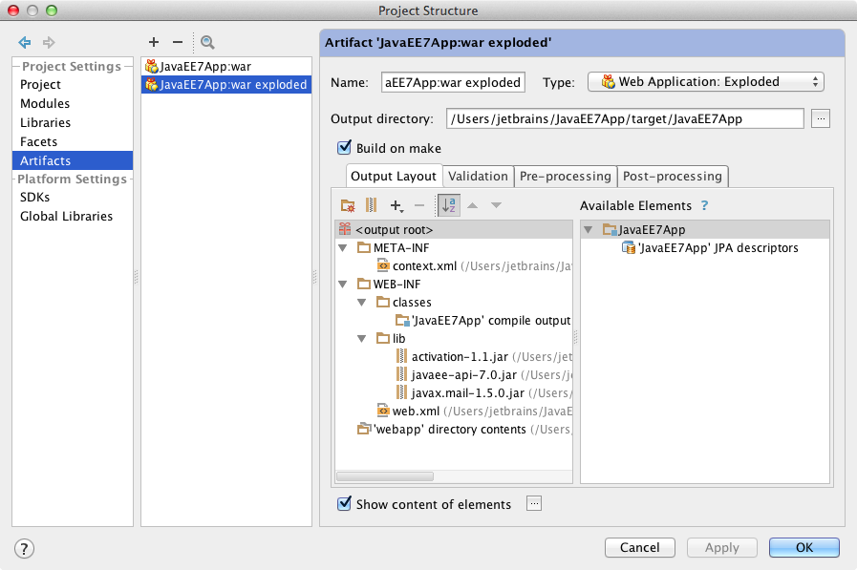

If you use Maven or Gradle, you don’t need to configure the artifacts manually. The IDE automatically synchronizes them with the artifacts defined in your build files.

### **4. Run configurations**

A Run configuration defines how the artifacts are deployed to the server. IntelliJ IDEA has two types of Run configurations: Local andRemote. The Local run configuration starts a new instance of the server and deploy artifacts there. The Remote run configuration deploys the artifacts to an already running standalone server.

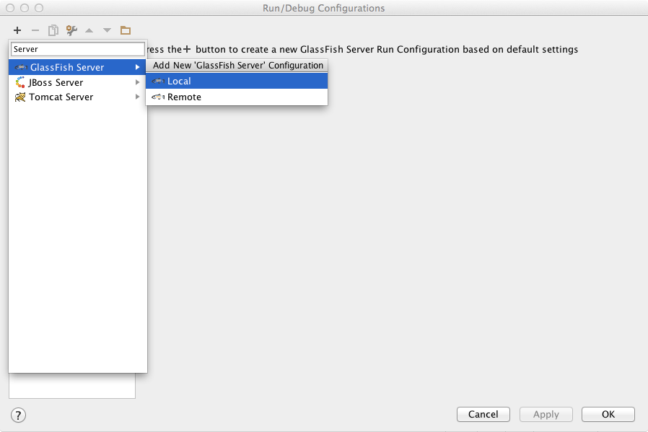

Each application server may have a different set of parameters in a Run configuration.

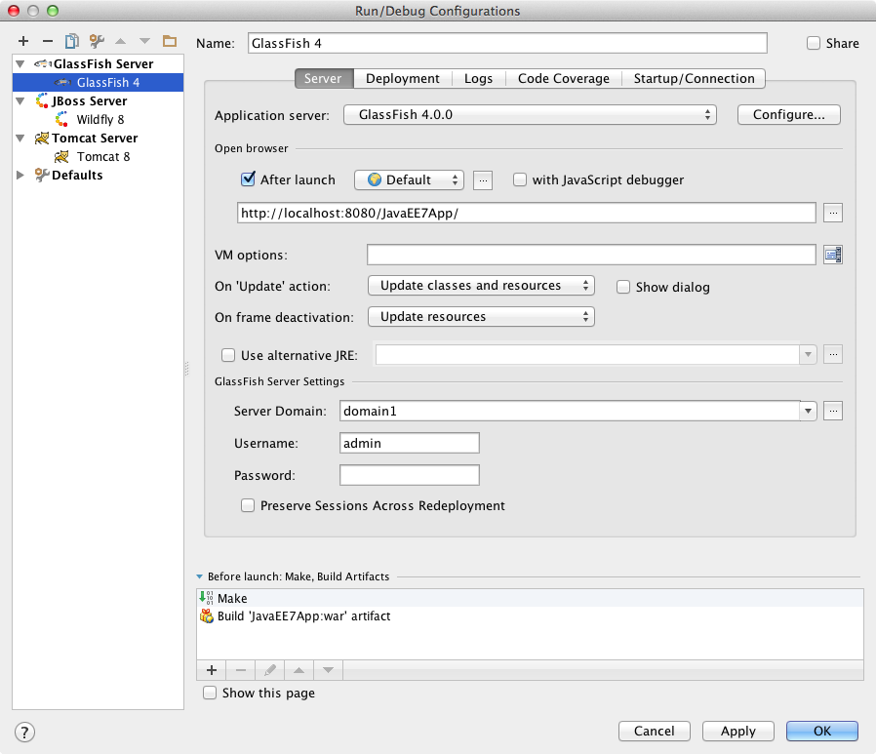

One important parameter here is On ‘update’ action, which defines how to update the application when you use the Update action via Ctrl+ F10 (Cmd+ F10 for Mac). Based on your choice, the IDE can update resources, update classes and resources, or redeploy orrestart the server. Turn off the Show dialog checkbox if you don’t like to see the dialog each time you update the application. This is a great time-saver when you update your application very frequently.

Another important parameter is the On frame deactivation, which defines how to update the application when you switch from the IDE, say to a browser. Based on these settings, the IDE can update resources, update classes and resources, or do nothing. This setting may be very useful when you’d like to have your application updated automatically each time when you switch to a browser.

Keep in mind that update resources and update classes and resources options are available only for the Exploded artifact type. For theArchive artifact type use the common HotSwap.

By default, the IDE runs the application server using the project JRE. However, you can always choose to use an alternative JRE.

An essential part of any Run configuration is the artifacts deployment.

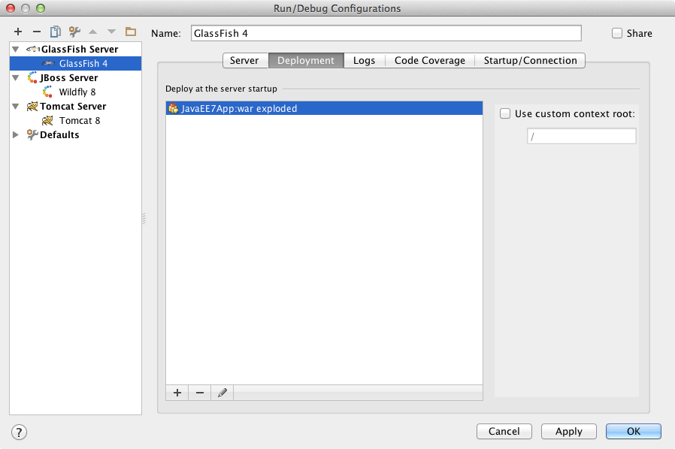

By default, the IDE automatically builds the artifacts before deploying. However you can change it using the Before launch group in theRun configuration dialog.

A Remote run configuration has additional parameters such as the host/port of the server you’d like to deploy your artifacts to.

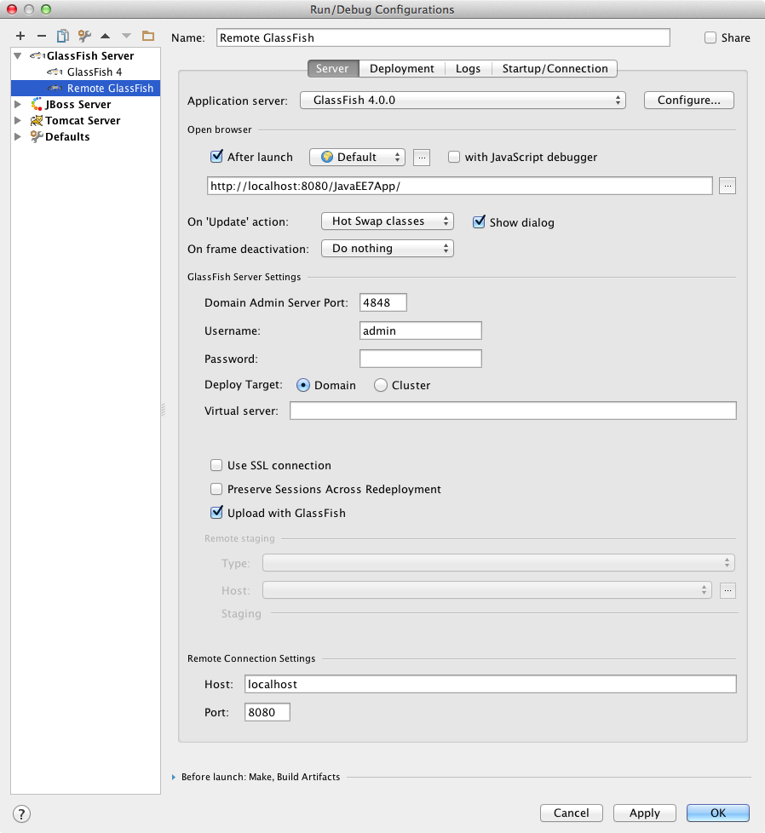

### **5. Run and debug application**

Once a Run configuration is created, you can run or debug your application via the Toolbar, menu Run or the shortcuts: Run via Shift+ F10, Debug via Shift + F9.

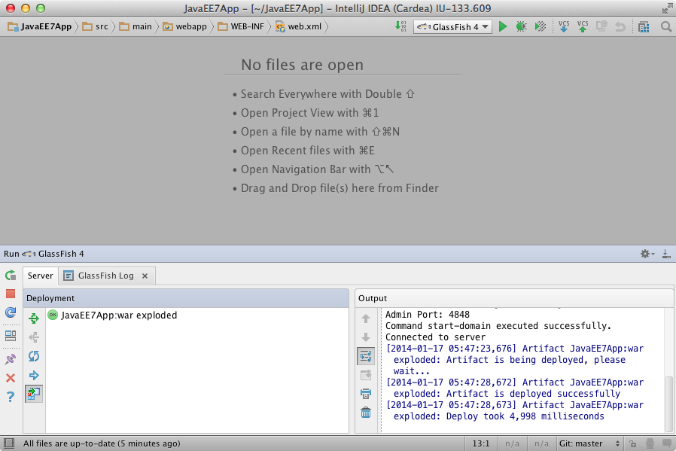

### **6. Update and HotSwap**

When you need to apply changes in the code to a running application, we recommend using the Update action via Ctrl + F10 (Cmd +F10 for Mac). As mentioned above, the Update action is only available for the Exploded artifact type. Based on your choice, it canupdate resources or update classes and resources. When the Update action is applied in the Debug mode, it uses the HotSwap; otherwise, it uses the Hot redeployment.

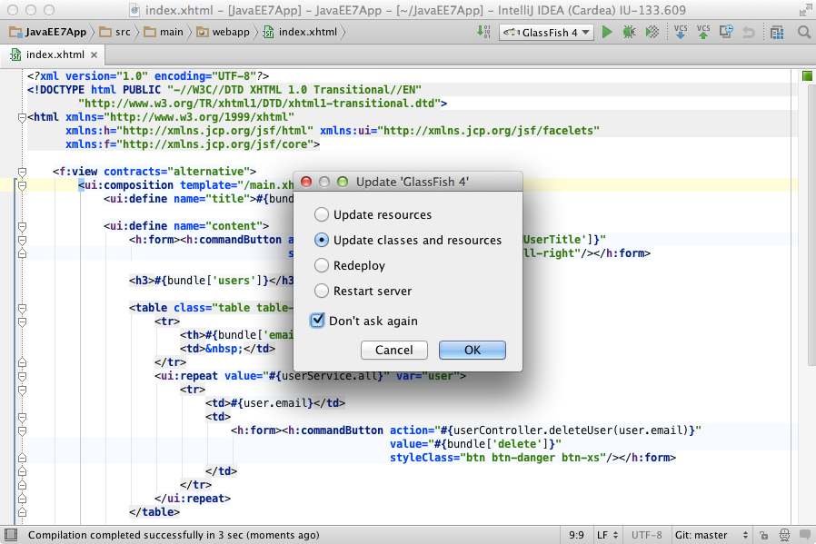

If you use the Archive artifact type you can only rely on the HotSwap, which is done automatically when you are in the Debug mode.

### **7. Build artifacts**

You can always ask the IDE to build your artifacts on via the Build → Build artifacts action.

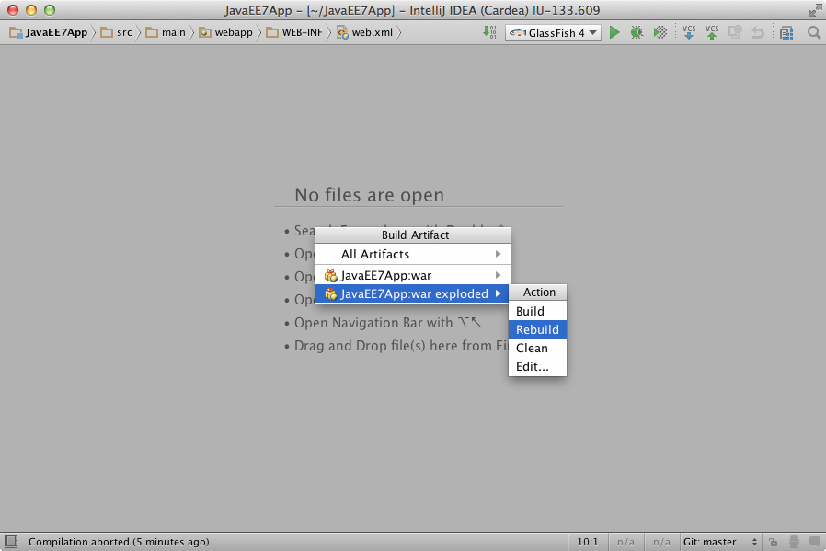

### **8. Application servers tool window**

Each Run configuration is shown in the Application servers tool window, along with the server and artifacts state. This tool window also helps you easily Run/Stop the server and Deploy/Undeploy/Configure artifacts.

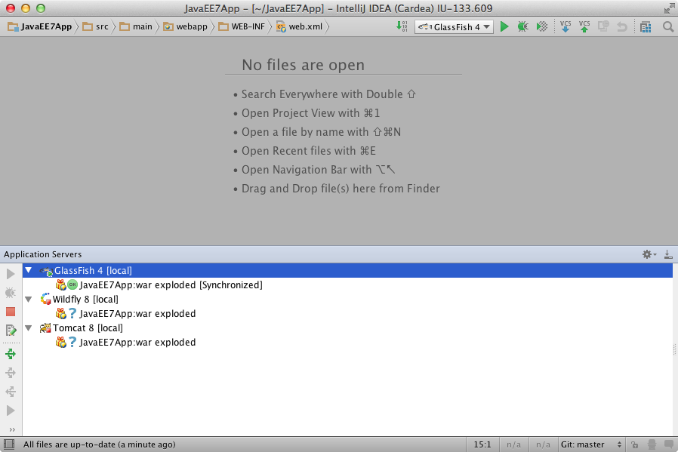

|  |
| --- |
| See also [Getting Started with Java EE 7 and GlassFish 4.0](https://confluence.jetbrains.com/display/IntelliJIDEA/Getting+Started+with+Java+EE+7+and+GlassFish+4.0) on how to create, configure, deploy and debug Java EE 7 application using GlassFish 4.0. |

## [official blog](http://blogs.jetbrains.com/idea/)

# [Tutorials](https://confluence.jetbrains.com/display/IntelliJIDEA/Tutorials)

## [Web Development](https://confluence.jetbrains.com/display/IntelliJIDEA/Web+Development)

## [Basics](https://confluence.jetbrains.com/display/IntelliJIDEA/Basics)

## [Scala Development](https://confluence.jetbrains.com/display/IntelliJIDEA/Scala+Development)

### [Scala](https://confluence.jetbrains.com/display/IntelliJIDEA/Scala)

|  |
| --- |
| See also the tutorial [Getting Started with Play 2.0](https://confluence.jetbrains.com/display/IntelliJIDEA/Play+Framework+2.0) to learn how to create web applications with Scala. |

### Getting Started with Scala in IntelliJ IDEA

Before you perform the tutorial's steps we recommend you to watch the video with a quick overview of Scala support in IntelliJ IDEA.

#### 1. Install plugin

Before you create your first Scala application make sure Scala plugin is installed and enabled via Settings → Plugins.

#### 2. Create Scala project with project wizard

Open Project Wizard and select Scala template. Specify home directory for Scala. If you don't have it, you can get it via Download button.

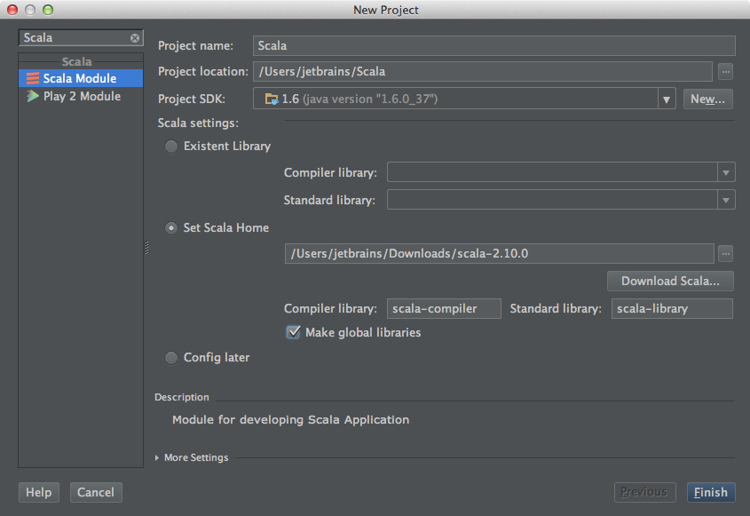

It will be easier next time to create applications if you select to make global libraries.

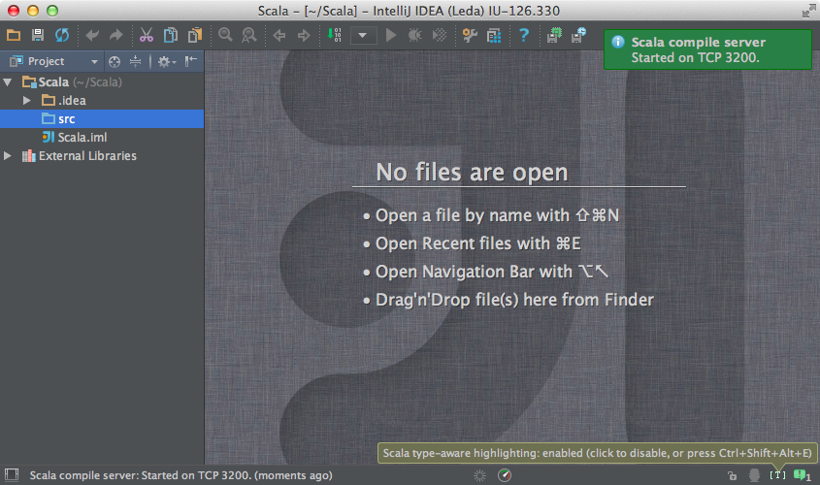

#### 3. Check project libraries

Open Project Structure and check the project libraries. Here you can configure additional libraries, e.g. ScalaTest or any others.

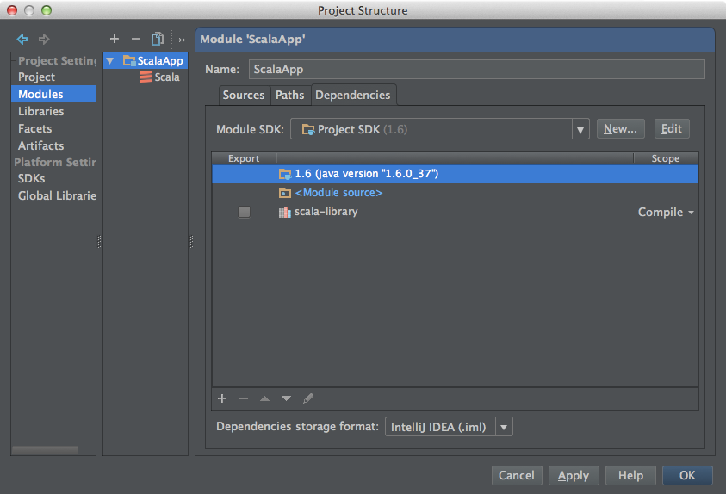

**Check compiler settings**

In Scala Facet settings you can check Compiler options.

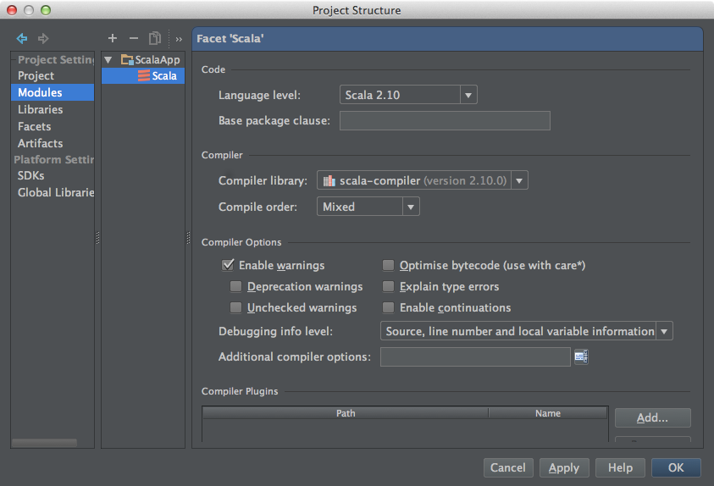

#### 4. Create object

The easiest way to create Scala file, worksheet or script is to use Ctrl + N shortcut from Project View or Navigation Bar.

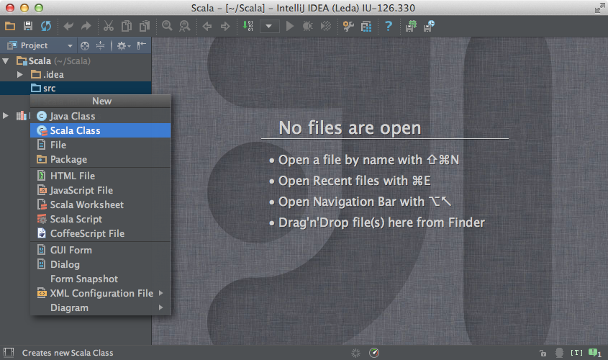

Choose between class, object and trait with Up and Down arrows.

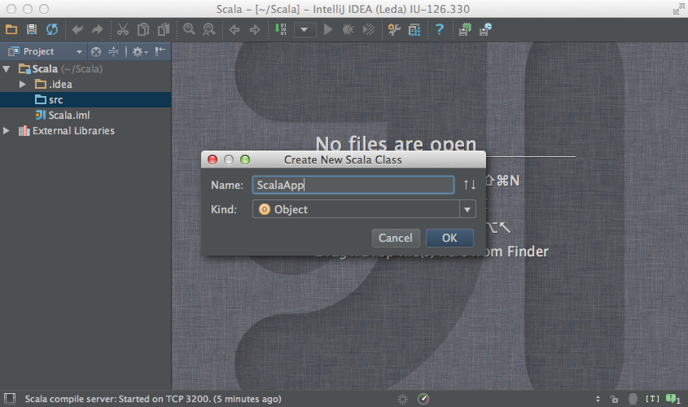

#### 5. Run application

The fastest way to run the code at cursor is to use Ctrl + Shift + F10 shortcut.

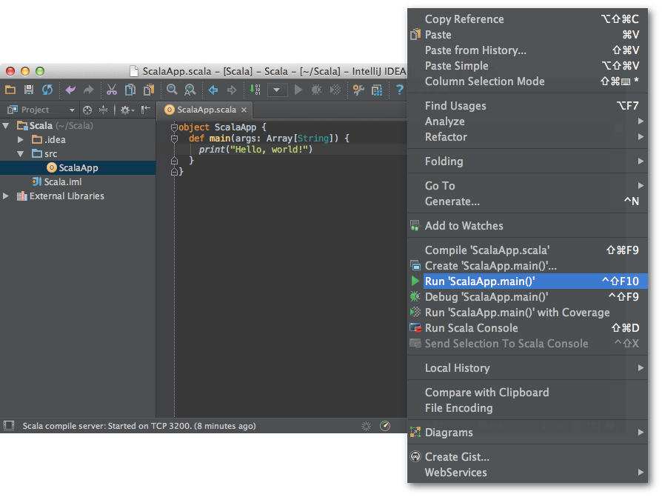

Alternatively you can use the context menu.

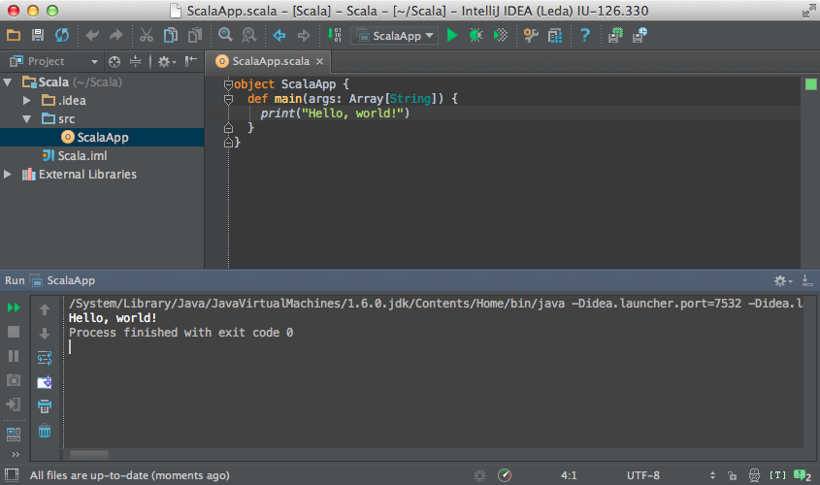

|  |
| --- |
| See also the tutorial [Getting Started with Play 2.0](https://confluence.jetbrains.com/display/IntelliJIDEA/Play+Framework+2.0) to learn how to create web applications with Scala. |

**Labels:**

None

##### [5 Comments](https://confluence.jetbrains.com/display/IntelliJIDEA/Scala)

[comments.show.hide](https://confluence.jetbrains.com/display/IntelliJIDEA/Scala)

1. 

Jun 22, 2014

#### Anonymous

Unfortunately Check RegExp floating menu position that should appear after the combination of Alt+Enter is hit (with the cursor on the regexp) does not work for me (IntelliJ Idea 13.1.3 Ultimate on Ubuntu 13.10) in Scala sources (it does work if I edit Java files though).

* + [Permalink](https://confluence.jetbrains.com/display/IntelliJIDEA/Scala?focusedCommentId=54332396#comment-54332396)
  + [Reply](https://confluence.jetbrains.com/pages/replycomment.action?commentId=54332396&pageId=50500556)
  + 

Jun 24, 2014

#### Anonymous

Correct! It doesn't work for me either (Intellij Idea 13 Ultimate on OSX 10.9) when editing scala source. Please fix it!

* + - [Permalink](https://confluence.jetbrains.com/display/IntelliJIDEA/Scala?focusedCommentId=54332776#comment-54332776)
    - [Reply](https://confluence.jetbrains.com/pages/replycomment.action?commentId=54332776&pageId=50500556)

1. 

Dec 18, 2014

#### Anonymous

The article is quite out-of-date, could you rewrite it?

* + [Permalink](https://confluence.jetbrains.com/display/IntelliJIDEA/Scala?focusedCommentId=57287579#comment-57287579)
  + [Reply](https://confluence.jetbrains.com/pages/replycomment.action?commentId=57287579&pageId=50500556)

1. 

Dec 31, 2014

#### Anonymous

Doesn't work with Intellij Idea 14 -- can you record this video for v14?

* + [Permalink](https://confluence.jetbrains.com/display/IntelliJIDEA/Scala?focusedCommentId=57288873#comment-57288873)
  + [Reply](https://confluence.jetbrains.com/pages/replycomment.action?commentId=57288873&pageId=50500556)

1. 

Dec 31, 2014

#### Anonymous

This is great if you are on IntelliJ 12. How about keeping up to date with IntelliJ 14? The irony is that I upgraded from 12 to 14 so to have better scala support :(

* + [Permalink](https://confluence.jetbrains.com/display/IntelliJIDEA/Scala?focusedCommentId=57288874#comment-57288874)
  + [Reply](https://confluence.jetbrains.com/pages/replycomment.action?commentId=57288874&pageId=50500556)

### [Working with Scala Implicit Conversions](https://confluence.jetbrains.com/display/IntelliJIDEA/Working+with+Scala+Implicit+Conversions)

Scala implicit conversions is a powerful tool for Scala coding.  It lets you decrease redundancy in your code and lets you make the code easier to read.

Scala implicit conversions feature enables you to do the following:

* Highlight methods in which implicit converions were used.
* Select from the available list of all applicable implicit conversions.
* Apply conversion either explicitly or in shorter version and still get the same result.
* Invoke implicit parameters.

#### Implicit Conversion highlighting

If Scala type-aware highlighting  is enabled then IntelliJ IDEA highlights methods that are added via implicit conversions with a grey underline:   
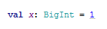

#### Invoking implicit conversion methods

Select an expression and press Ctrl+ Shift+ Q (Ctrl+Qfor Mac) to invoke the list of applicable implicit conversions.  The list shows the regular scope displayed on the top and the expanded scope that is displayed on the bottom of the list.

|  |  |
| --- | --- |
| https://confluence.jetbrains.com/images/icons/emoticons/warning.gif | **Note:** IntelliJ IDEA highlights an implicit converion that was used for the selected expression. If IntelliJ IDEA cannot find the implicit conversion or if it finds more than one match then the list **Introduce Variable** opens. |

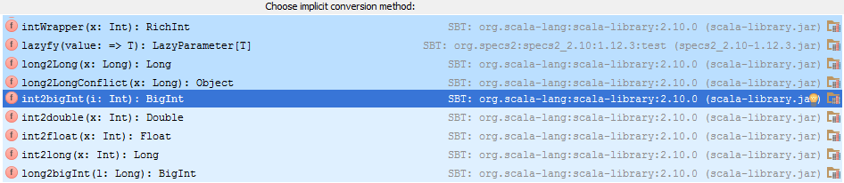

You can make the implicit conversion method explicit. Press Alt+ Enterand select **Make explicit** or **Make explicit (Import method)** :   
  
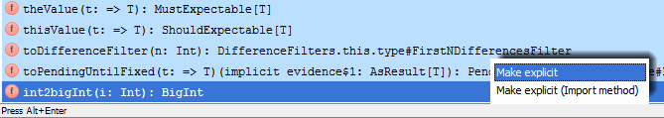

If you select **Make explicit** then IntelliJ IDEA returns a method call with the class name. It might be helpful if you need to make sure that the compiler imports the particular implicit conversion method that you originally wanted:   
  


If you select **Make explicit (Import method)** then the method is imported statically and IntelliJ IDEA returns just its call without the class name. Also, the next time you open the list of useful implicit conversions you will see this method in the regular scope:   
  


#### Invoking implicit parameters

Place a cursor to the method where implict conversion was used and press Ctrl+ Shift+ P(Meta+ Shift+ Pfor Mac) to invoke implicit parameters. It might be helpful for code analizing when you want to find out what implicit parametrers were passed to the particular call. IntelliJ IDEA also lets you view the recursive implicit parameters.

|  |  |
| --- | --- |
| https://confluence.jetbrains.com/images/icons/emoticons/warning.gif | **Note:**  IntelliJ IDEA hightlights the method call where implicit parameters were used. |

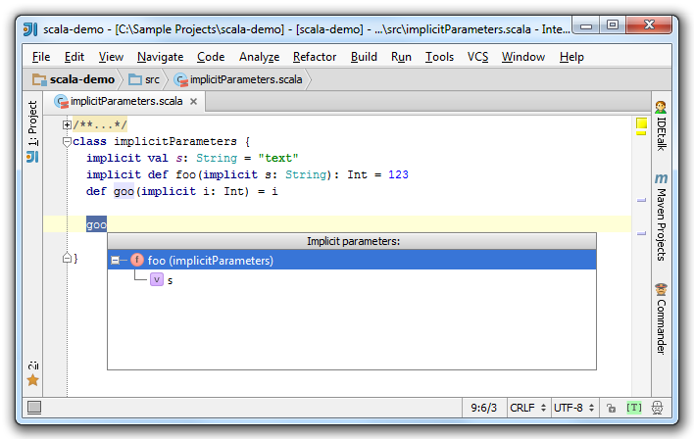

If IntelliJ IDEA cannot find method calls where implicit paramerers were passed,  it displays a pop-up message:   
  


|  |  |
| --- | --- |
| https://confluence.jetbrains.com/images/icons/emoticons/warning.gif | See also the tutorial [Getting started with Scala in IntelliJ IDEA](https://confluence.jetbrains.com/display/IntelliJIDEA/Scala). |

**Labels:**

None

#### [1 Comment](https://confluence.jetbrains.com/display/IntelliJIDEA/Working+with+Scala+Implicit+Conversions)

[comments.show.hide](https://confluence.jetbrains.com/display/IntelliJIDEA/Working+with+Scala+Implicit+Conversions)

1. 

Oct 21, 2014

##### Anonymous

"lets you make the code easier to read."

typical scala style. It is indeed much easier to read -- but not for reader/maintainer

It is easier for the writer, much harder to reader.

### [Working with Scala Show Type Info Action](https://confluence.jetbrains.com/display/IntelliJIDEA/Working+with+Scala+Show+Type+Info+Action)

|  |
| --- |
| IntelliJ IDEA offers an easy way to work with type inference feature such as Scala Show Type Info action. |

#### 1. Enter Code

Let's enter a random code and see what can be done:     
   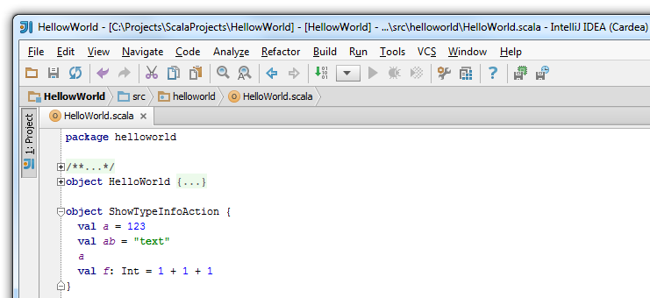

#### 2. Invoke Show Type Info Action

|  |  |
| --- | --- |
| https://confluence.jetbrains.com/images/icons/emoticons/warning.gif | If you select **Show type info on mouse motion** check box in Settings → IDE Settings → Scala, then in the Editor, you can simply navigate with the mouse to a value to see its type information. |

To invoke Show Type Info action in Editor, navigate to the value and press Alt+ = (Ctrl+ Shift+ P for Mac):    
  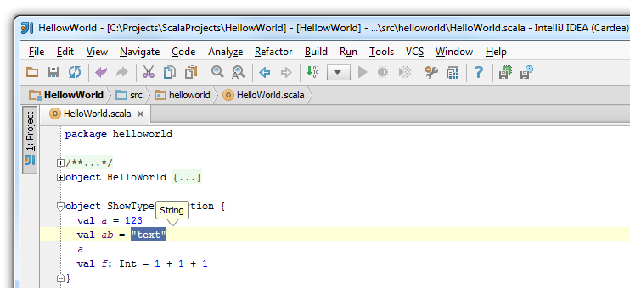

You can also see the type information on a value definition. Simply put the caret on a value definition and press Alt+ = (Ctrl+ Shift+P for Mac):

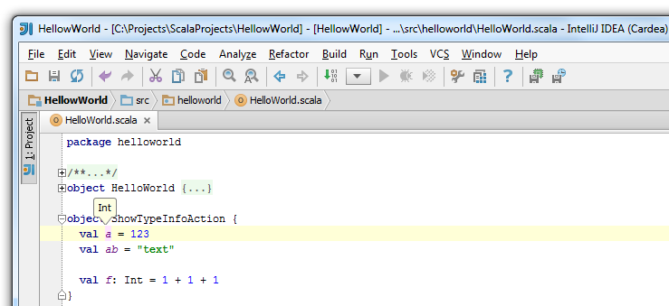

#### 3. Add Type Annotation

To add a type annotation, highlight the value and press Alt+ Enter:

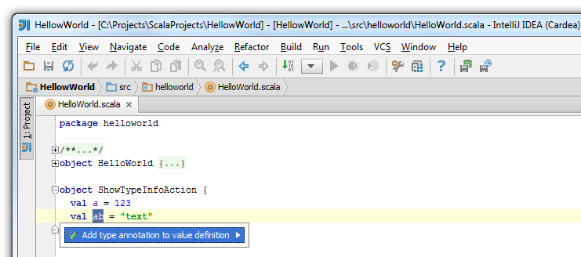

As a result, the type annotation is added:   
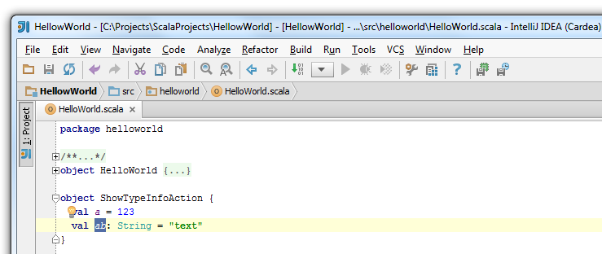 

#### 4. Remove Type Annotation

You can also remove the type annotation the same way you have added it, by pressing Alt+ Enter:   
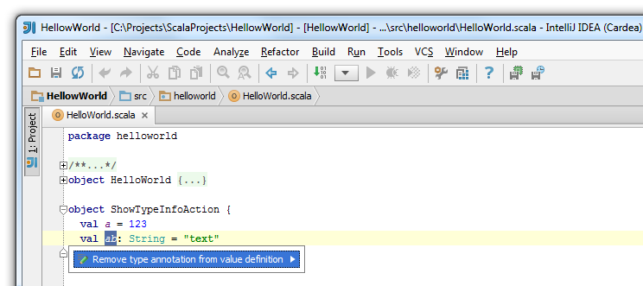 

#### 5. See Type Annotation on Expression

To see the type information on an expression, simply  navigate to the expression, highlight it and  press Alt+ = (Ctrl+ Shift+ P for Mac):

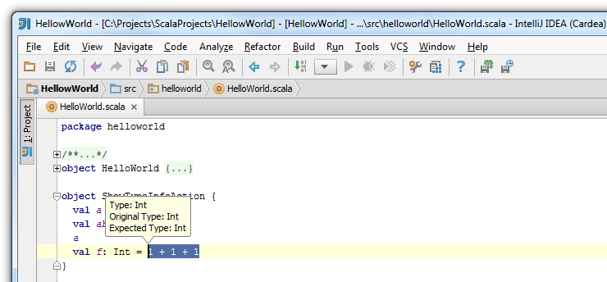

### [Working with Scala Worksheet](https://confluence.jetbrains.com/display/IntelliJIDEA/Working+with+Scala+Worksheet)

Intellij IDEA lets you create a Scala worksheet that enables you to evaluate your Scala code results in a special view of the Scala editor.

#### 1. Creating Scala Worksheet

To create a Scala Worksheet, right-click on your project and select New→ Scala Worksheet:    
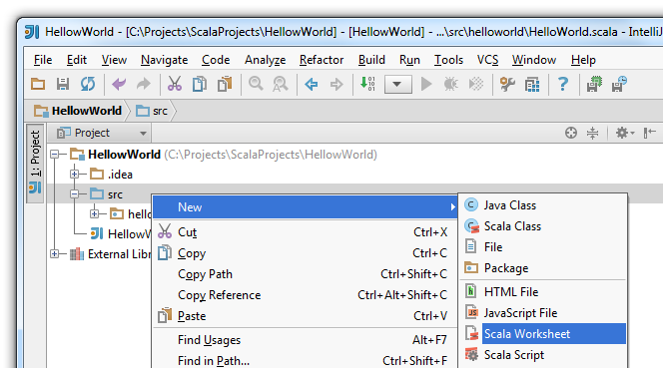

|  |  |
| --- | --- |
| https://confluence.jetbrains.com/images/icons/emoticons/warning.gif | It is recommended to create your worksheet in src directory to simplify an inclusion of the project's classes in the classpath. That might be helpful for testing purposes. |

In the New Scala Worksheet window type a name of your Scala worksheet and click OK.   
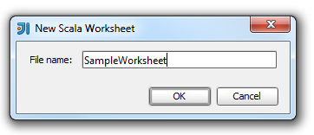   
As a result, a file with .sc extension opens. Now you can enter your code.

#### 2. Running Scala Worksheet

You can enter your code and press   to see the results. You can clear the Make project check box to improve evaluation performance. In this case, the automatic checking of project's changes is disabled.

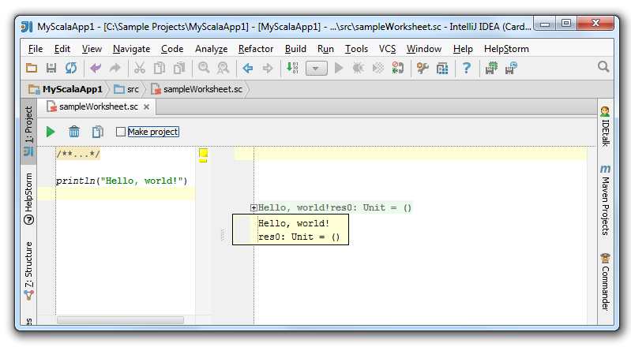

The results appear in the view on the right side of your code.

A Scala object could be also evaluated. Let's see the following code and the results:   
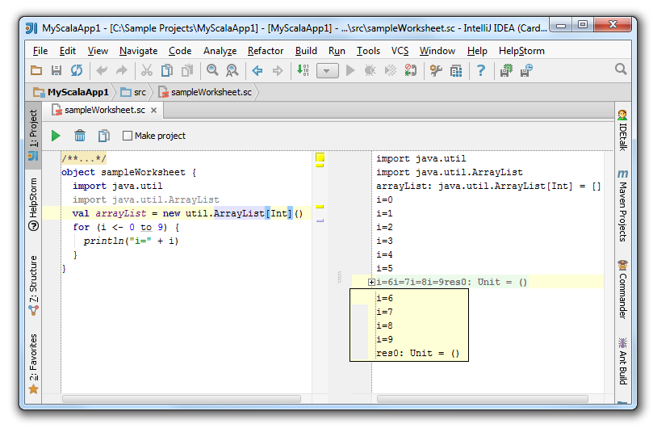

You can fold the output without affecting your code on the left side and expand only that block output that matches a specific statement.

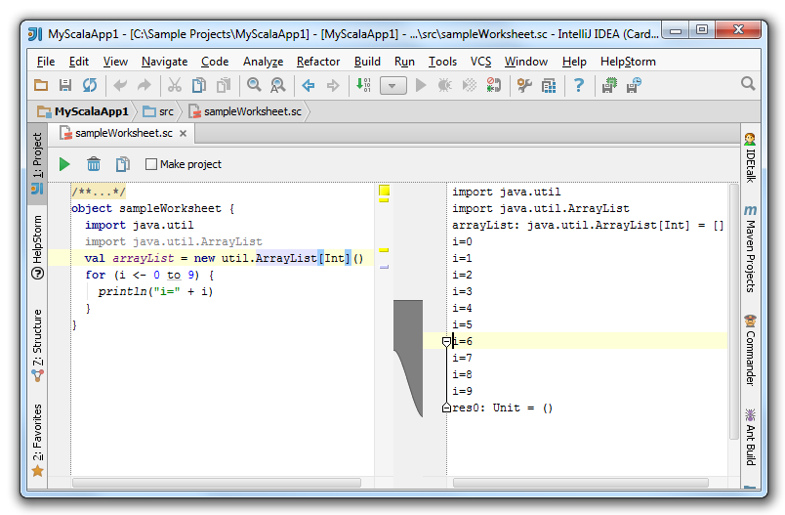

#### 3. Removing Worksheet's Results

You can remove the worksheet's results easily by pressing  icon.

#### 4. Copying Actions

You can easily copy your code and evaluation results into one file by clicking  icon.    
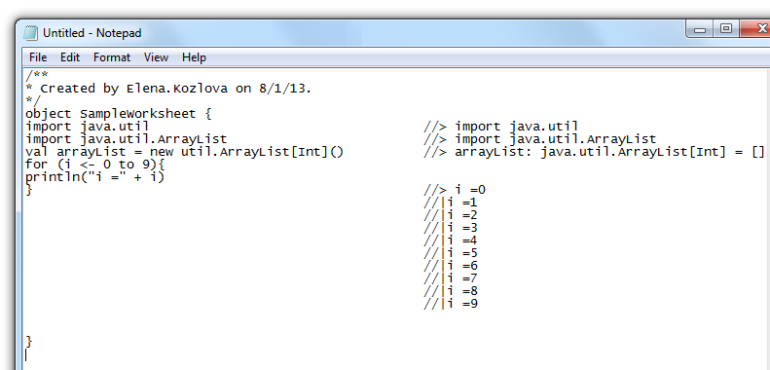

#### 5. Configuring Worksheet Settings

You can configure your worksheet's settings by selecting File→ Settings→ Scala, on the main menu, and clicking Worksheet tab.

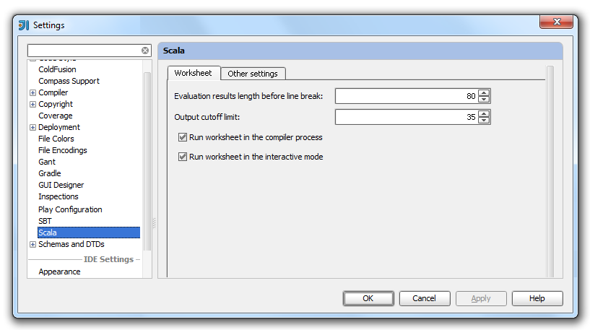

On the **Worksheet** tab, you can set the length for the line break of your results and the output cutoff limit.   
You can also configure in what mode you want to run the worksheet.

### [Working with Type-Aware Highlighting](https://confluence.jetbrains.com/display/IntelliJIDEA/Working+with+Type-Aware+Highlighting)

Scala type-aware highlighting lets you get an error analysis based on the Scala's type system before you start a compilation process.

 You can enable or disable the type-aware highlighting in the following ways:

* On the project level, by selecting the appropriate check box on the first page of the project wizard or by clicking the   icon on the status bar.
* On the file level of your project, by clicking the   icon on the status bar.
* Locally in Editor, by using   Surround With action.

#### 1.How to Enable or Disable Type-Aware Highlighting on the Project Level

On the first page of the new project wizard, you can see a check box Enable type-aware highlighting, by default, it is selected.  If you need to disable the type-aware highlighting, simply uncheck this option.

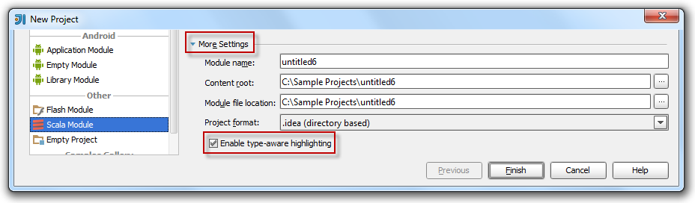

 You can always enable or disable a type-aware highlighting for your project by clicking  icon on the status bar or using a Ctrl+ Alt+Shift+ E shortcut.

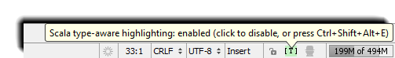

#### 2. How to Enable or Disable Type-aware Highlighing on the File Level

 You can enable or disable the type-aware highlighting for the specific file in your project. To do that, open the file and on the status bar click  Hector icon. If you disable Hector, then the type-aware highlighting will be also disabled.

Each time you enable or disable the type-aware highlighting, you can see the notification of the status's change in the Event log:   
  
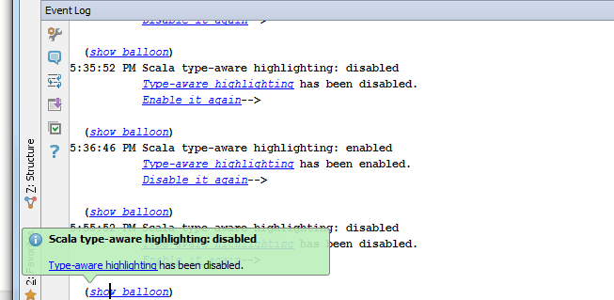

#### 3. How It Works

Let's see how it works:   
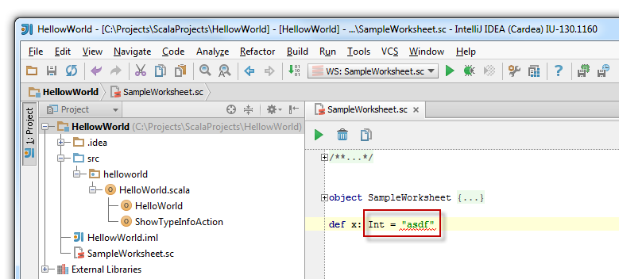 

As you can see, the expression is wrong and the value is highlighted. If the type-aware highlighting is disabled, the error is not highlighted and it might be quite difficult to spot.

You can also enable the higlighting based on expression type inference. Consider the following example: 9  
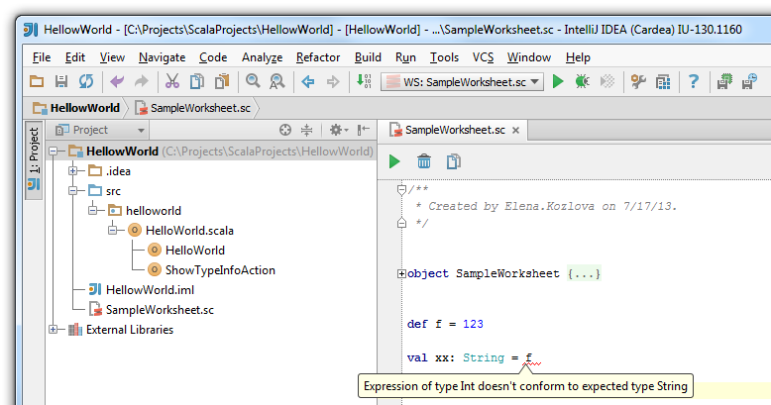   
  
 As the pop-up message suggests, the expression type is wrong and is highlighted.

#### 4. How to Disable Type-Aware Highlighting Locally

You can disable the type-aware highlighting locally using Surround With action. To do that, highlight the code and on the main menu selectCode→ Surround With.  When Surround With window opens, select / * _ * /.../ * _ * / option from the list. Consider the following example:   
  
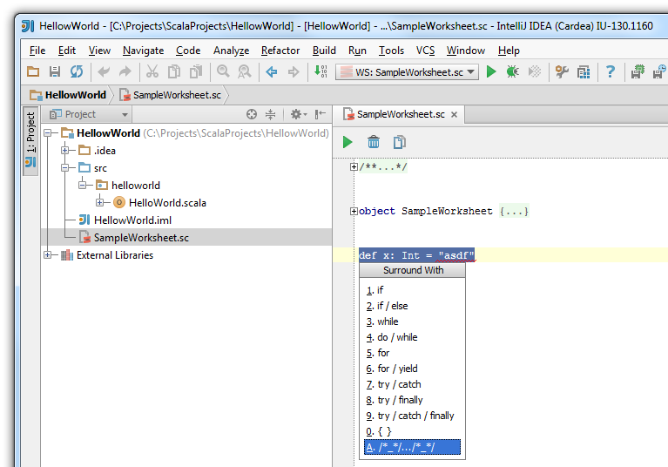

After you've selected the apporpriate option your code looks like this :   
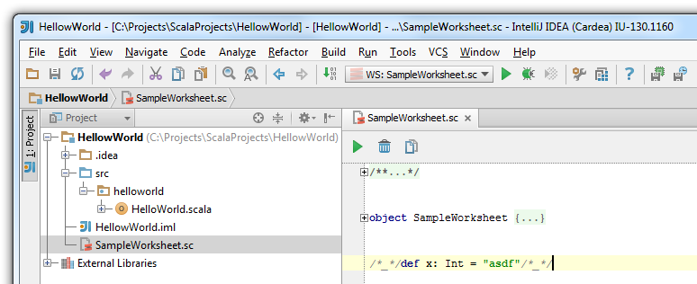   
As a result, the error is not highlighted.

**Labels:**

### [Working with Scala Compiler](https://confluence.jetbrains.com/display/IntelliJIDEA/Working+with+Scala+Compiler)

IntelliJ IDEA version 12.0 offers a new approach to Scala compilation process of your Scala project.

|  |  |
| --- | --- |
| https://confluence.jetbrains.com/images/icons/emoticons/warning.gif | For the information on how to create a Scala project, please see [Scala](http://confluence.jetbrains.com/display/IntelliJIDEA/Scala) tutorial. |

#### 1. To Configure Compiler Settings in Project Structure

Open your project and on the **Tool Bar**, click  icon to open the **Project Structure** page or select File→ Project Structure→Modules→ Scala.   
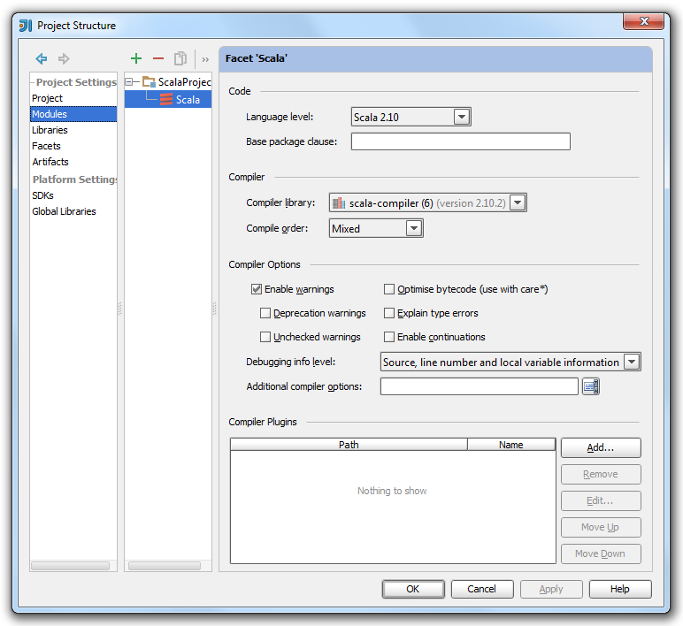

 On the **Project Structure** page, under **Facet 'Scala'** you can specify  the following compiler settings:

* **Compiler library** -  The compiler library is defined in Scala plugin. If you specified a home directory for Scala when you created your project than the library is configured automatically. You can select the compiler library from the list if you didn't specify one earlier while creating your project.
* **Compiler order -** You can select a compiler order option from the list. The default option is **Mixed**.  If you need more information on what option to choose, click [here](http://www.scala-sbt.org/0.12.2/docs/Detailed-Topics/Java-Sources.html) .
* **Compiler options** - You can select different compiler parameters such as warnings,  type error explanation and other information for the **Additional compiler options** field.

#### 2. To Configure Scala Compile Server Settings

 You can configure Scala compile server settings for your application.  To open the settings, select File→ Settings→ IDE Settings→Scala   
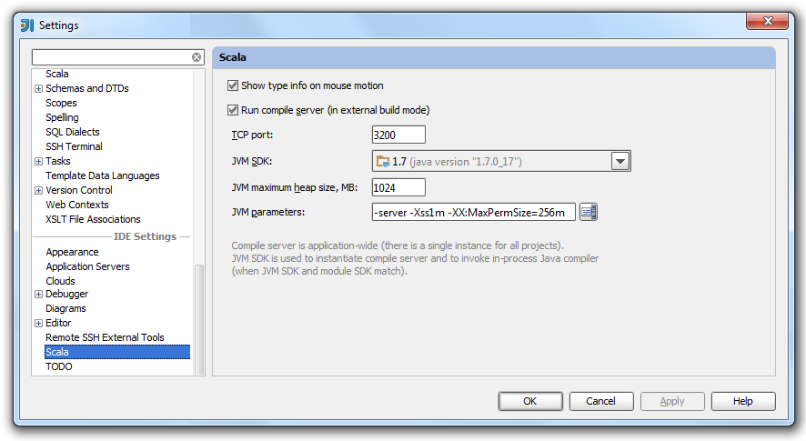

On this page, you can check or edit the **Run compile server** information. 

You can also invoke Scala compile server using  icon on the **Status Bar**.   
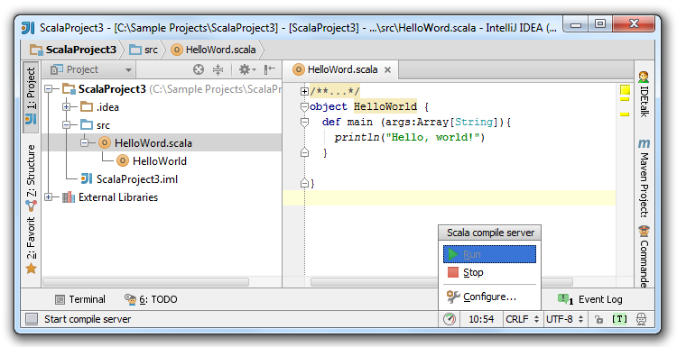   
You can use the available options  to start or  to stop your Scala compile server. You can also choose an option  to configure the Scala compile server settings.

#### 3. To See Compilation Messages

IntelliJ IDEA lets you view the results' messages of your compilation process in the **Message Compile** window:     
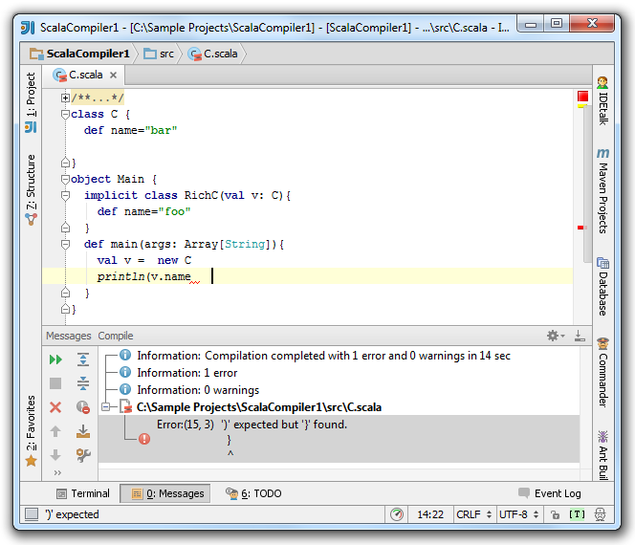  
 Depending on what you have selected in the compiler options, you are able to view different messages in the **Messages Compile**window.

### [Working with Scala Console](https://confluence.jetbrains.com/display/IntelliJIDEA/Working+with+Scala+Console)

IntelliJ IDEA lets you run Scala Console to quickly evaluate an expression or a code selection.

#### 1.Run Scala Console

Right-click on your Scala object and select **Run Scala Console** from the drop-down list.

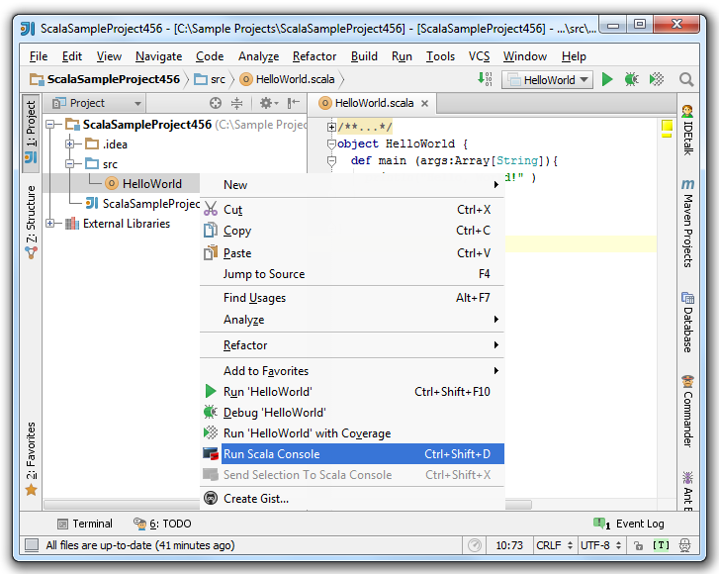

The **Scala Conslole** window opens.   
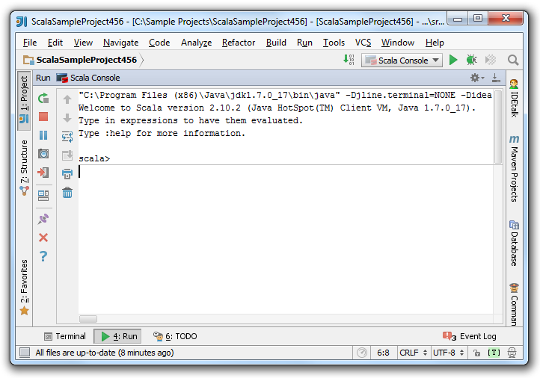

#### 2.Evaluate Code in Scala Console

You can type an expression in the console and evaluate it. You can also evaluate a code selection by sending it from the editor to the Scala console.   
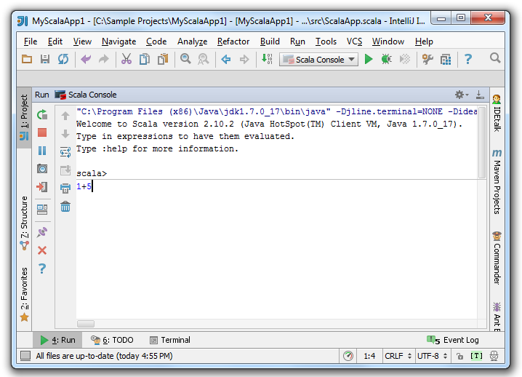 

To see the result of the typed expression, press Ctrl+ Enter.   
  
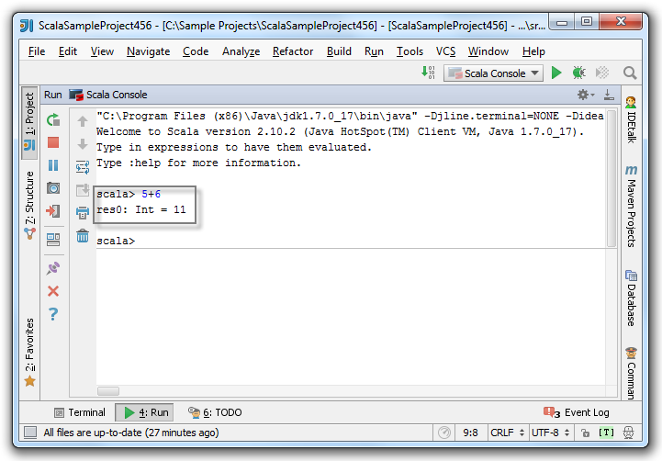

To send the code selection to Scala Console, select the code in the editor, press Ctrl+ Shift+ X (for Windows) or Meta+ Shift+X (for Mac).   
Alternatively, right-click on the code selection and from the context menu select **Send Selection To Scala Console** to get the same result. 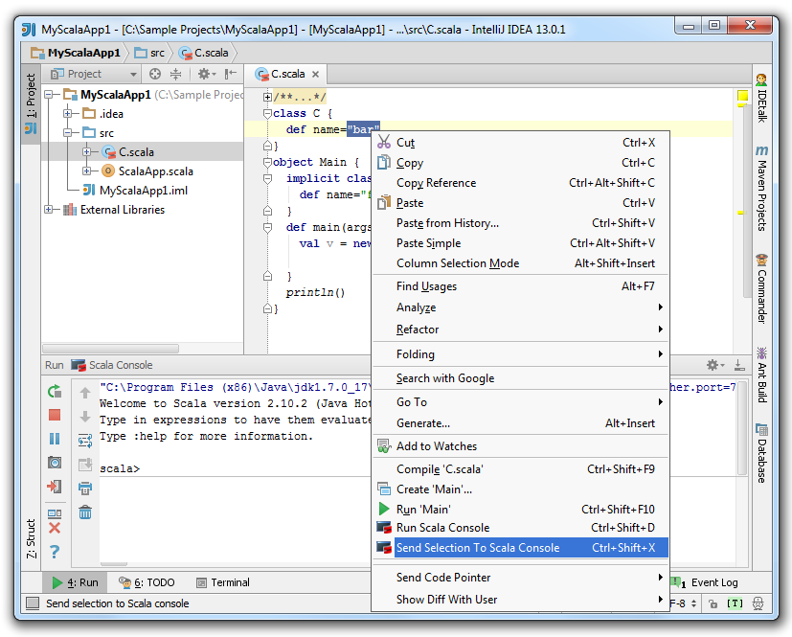

Now, you can view the selected code and its evaluation in the console.   
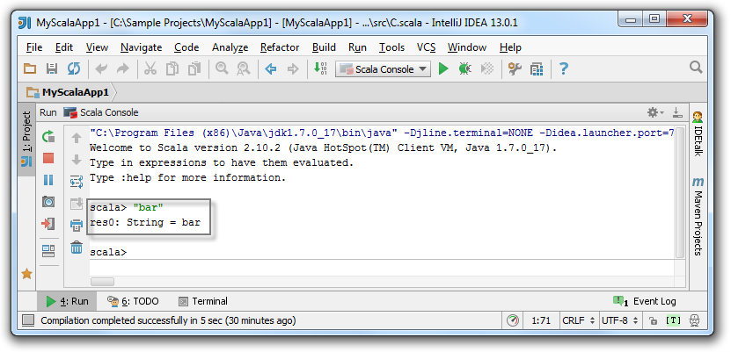 

#### 3.Use Toolbars in Scala Console

You can use **Run toolbar** and **Console toolbar** options to rerun, stop, pause, or terminate the Scala console.

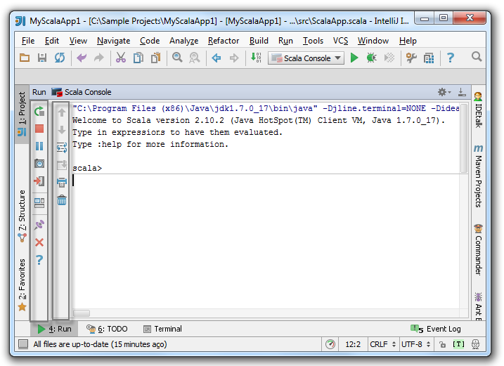 

#### [2 Comments](https://confluence.jetbrains.com/display/IntelliJIDEA/Working+with+Scala+Console)

[comments.show.hide](https://confluence.jetbrains.com/display/IntelliJIDEA/Working+with+Scala+Console)

1. 

Jul 07, 2014

#### Anonymous

Nice work, I'd like to point out though that paste mode is broken, there is actually no way to execute the block of code using shortcut ctrl + d ... I'm using scala plugin 0.38.437

* + [Permalink](https://confluence.jetbrains.com/display/IntelliJIDEA/Working+with+Scala+Console?focusedCommentId=54335566#comment-54335566)
  + [Reply](https://confluence.jetbrains.com/pages/replycomment.action?commentId=54335566&pageId=51963517)

### [Working with Strings in Scala](https://confluence.jetbrains.com/display/IntelliJIDEA/Working+with+Strings+in+Scala)

Intellij IDEA lets you add different intentions for strings and perform different actions with strings in Scala. Intellij IDEA also supports the Scala multi-line strings feature. This feature lets you format literals and helps your code to look more orderly.

#### 1. How to Insert Gap with Concatenation into a String

IntellijIDEA lets you insert a **gap with concatenation** intention. To do that, in your editor enter a string and press Alt+ Enter. The list of appropriate intentions opens.

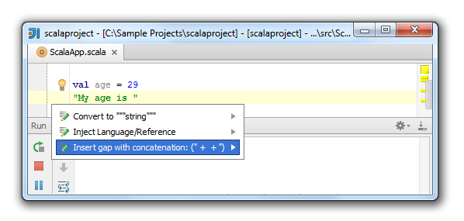

Select **Insert gap with concatenation ("+ +")** and press Enter.

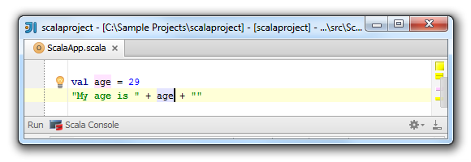   
Now you can insert a value into your string. You can evaluate the result in the **Scala Console** window.

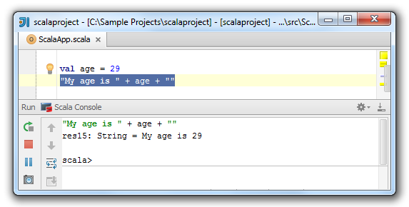

#### 2. How to Convert a String Concatenation into Interpolated String

For the Scala version 2.10 and later you have the ability to convert a string concatenation into the interpolated string.  
To do that, select a value with concatenation in your string and press Alt + Enter. The list of appropriate intentions opens.   
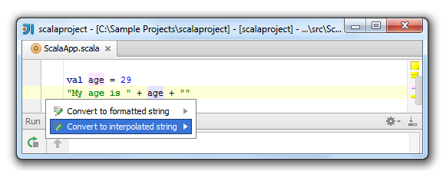   
Select **Convert to interpolated string**, press Enterand view the result.

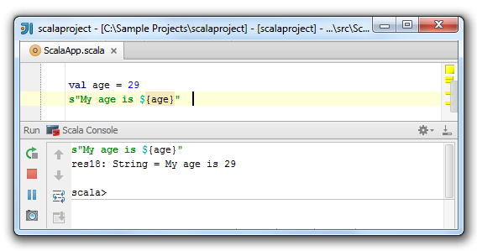   
You can also choose an option **Convert to formatted string** and get your basic Java formatted string.

#### 3. How to Convert a String into a Multi-line String and Vice Versa

You can convert your string into a multi-line string. Simply enter your string, press Alt + Enter and select **Convert to """string"""**option in the drop-down list of intentions.

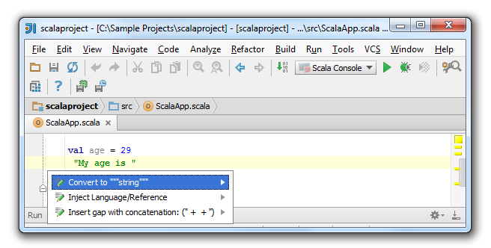   
Converting to multi-line strings removes escaped sequences such as '\\' or '\n'.

You also can convert the multi-line string into the regular string.  
Press Alt + Enter to open the drop-down list of intentions. Select **Convert to "string"** and press Enter.

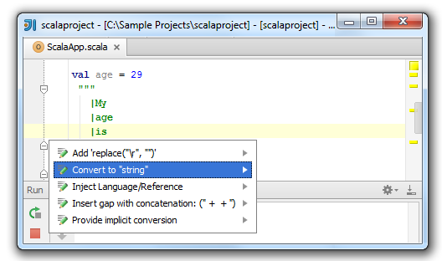   
View the result.

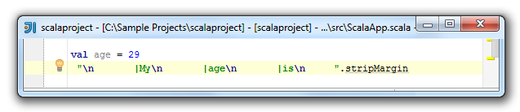

To start entering a multi-line string, simply type triple quotes in your editor.   
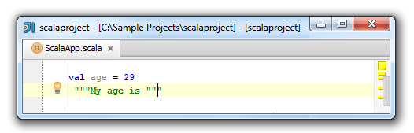

If you press Enter, it will automatically envoke **stripMargin** method. The **stripMargin** method removes the left-hand part of a multi-line string up to a specified delimiter.

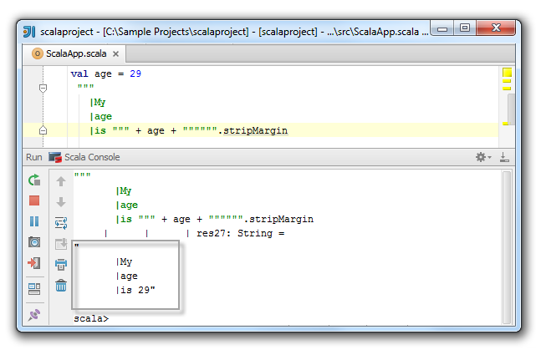

The white spaces are also preserved. Please see the following example:   
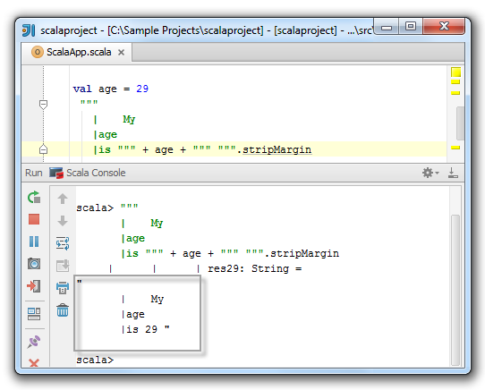

#### 4. How to Insert a Replace Intention

The **.replace("\r"," ")** intention lets you keep the caret in the correct place on the next line in the multi-line strings regardless of what operating system you have at the moment.  
Enter a multi-line string, press Alt + Enter and select the appropriate intention from the drop-down list.

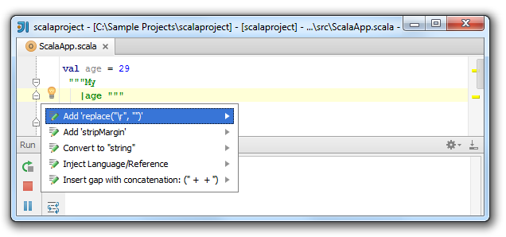

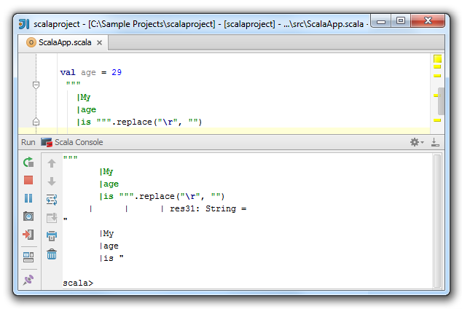

#### 5. How to Insert an Inject Language/Reference Intention

You can inject language or a reference into your multi-line string literals.  
Enter a multi-line string, press Alt+ Enterand select **Inject Language/Reference** intention from the drop-down list.

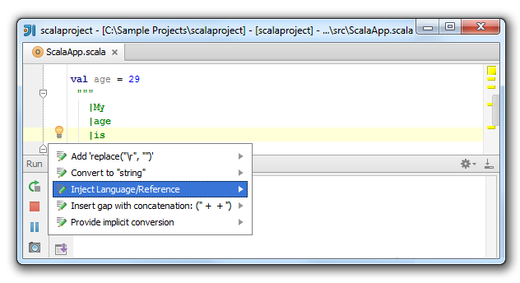   
The list of available languages opens. Choose the appropriate one and press Enter.

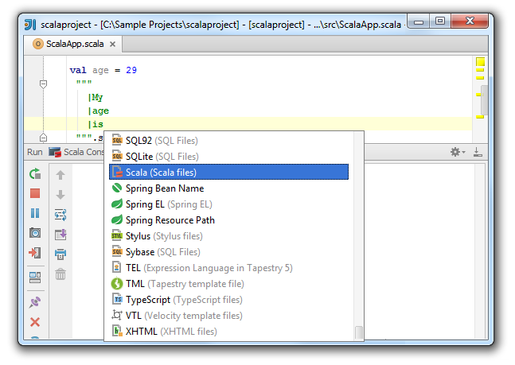   
To cancel the language injection, simply choose the **Un-Inject Language/Reference** intention.

#### 6. How to Edit Multi-line Strings Settings

You can set a different format for multi-line strings' options such as **Margin char indent** or **Margin Char**. You can also disable a multi-line strings support.  
To open the **Multi-line strings** settings, in the main menu select File→ Setting→ Project Settings→ Code Style→ Scala. On the**Scala** page select the **Multi-line strings** tab.   
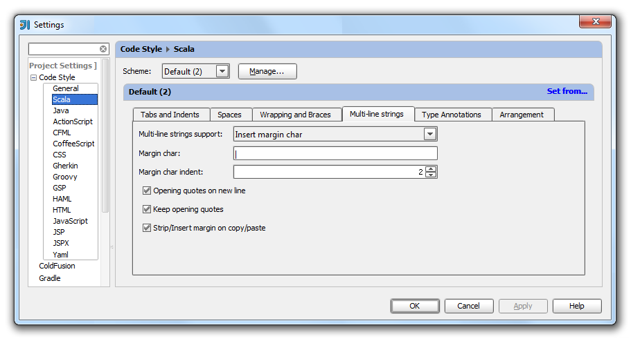

### [Getting Started with SBT](https://confluence.jetbrains.com/display/IntelliJIDEA/Getting+Started+with+SBT)

IntelliJ IDEA lets you create a new or import an existing project with a SBT module. SBT is a build tool for your Scala projects. You can also use SBT for Java projects.

#### 1. Create a New Project

Let’s create a new project from scratch. To do that, choose File→ New Project on the main menu, or click the **New Project** icon on the Welcome screen. On the first page of the New Project wizard, in the selector pane, choose **SBT**. On the right part of the page, enter the necessary information, such as project's name, its location and click **Finish**:

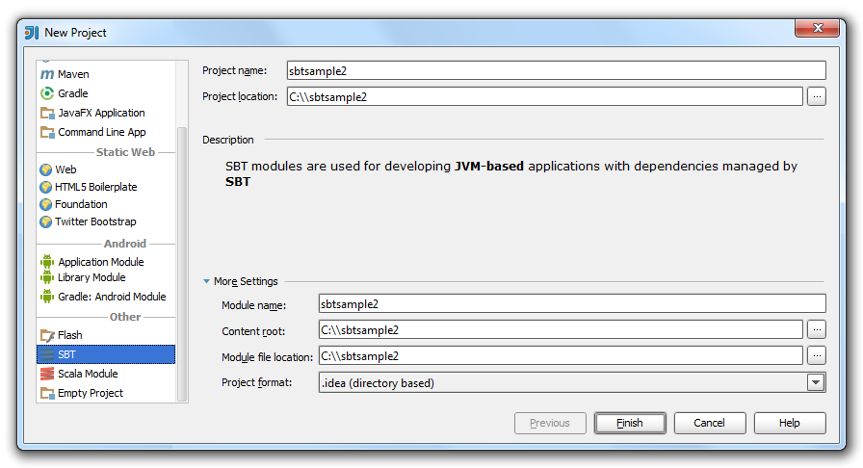

#### 2. View Project Tool Window

Intellij IDEA creates the following SBT-specific directories:

* target directory - this directory contains compiler-related information such as generated objects and classes.
* build.sbt file - in this file you can add dependencies, plugins, etc.
* SBT build directory - this directory contains build-related information such as configuration classes.   
  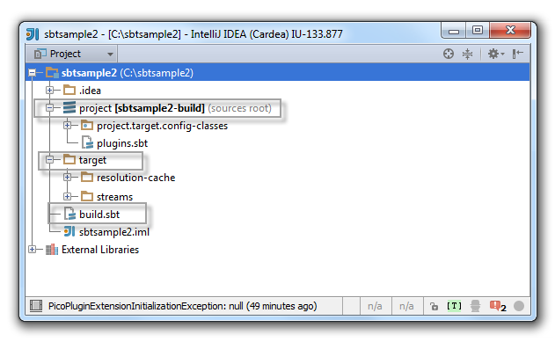

#### 3. View SBT Tool Window

IntelliJ IDEA also creates an SBT Tool window. You can use this window for adding tasks, refreshing your SBT projects, attaching or detaching external projects.

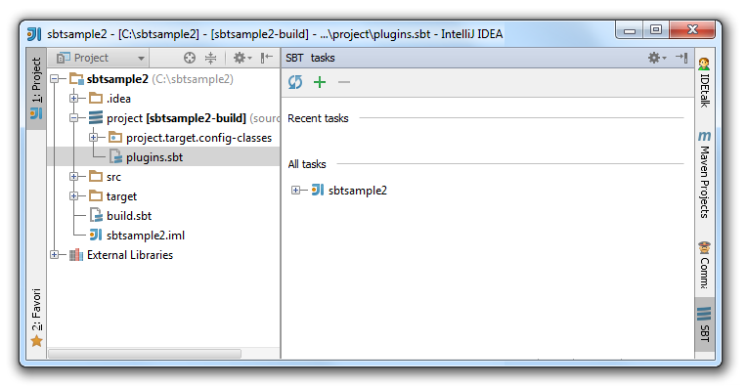

#### 4. Import SBT Project

IntelliJ IDEA lets you import an existing SBT project.   
To import an existing project, on the main menu select File→ Import Project. In the window that opens, select a file that you want to import and click **OK**.

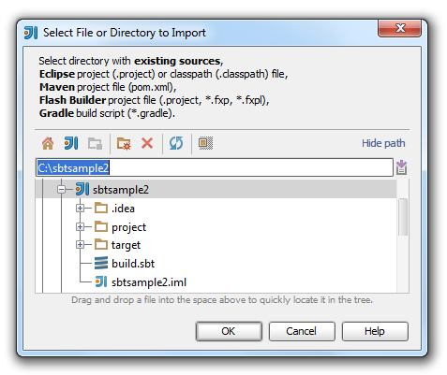   
The Import Project wizard opens.

On the first page of the wizard, select **Import project from external model** option and choose **SBT project** from the list. Click **Next**.   
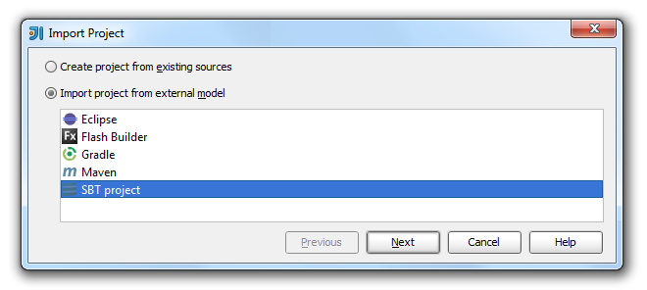   
On the next page of the wizard, select the following options:

* **Use auto-import** -select this check box to resolve all the changes made to the SBT project automatically every time you refresh your project.
* **Create directories for empty content roots automatically** - select this option to add a src directory to your project. When you import a project the scr directory is not created. When you create a project, the src directory is generated automatically.   
  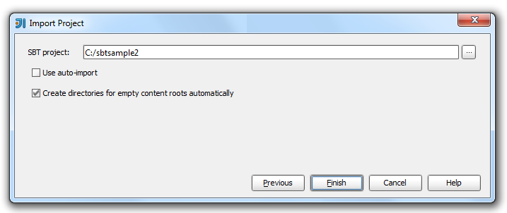   
  Click **Finish**.

#### 5. Add a Dependency to an SBT Project

IntelliJ IDEA lets you add and refresh dependencies in your SBT project.

To do that, open the build.sbt file and add a dependency.

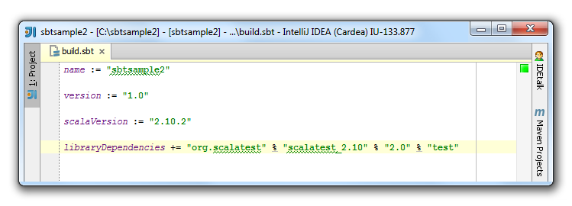

If you chose the **Use auto-import** option when you imported your project than your dependency is imported automatically.

If you didn't choose that option then after you have added your dependency in the build.sbt file, press  Refresh all SBT projects button in the SBT Tool Window to import the dependency.

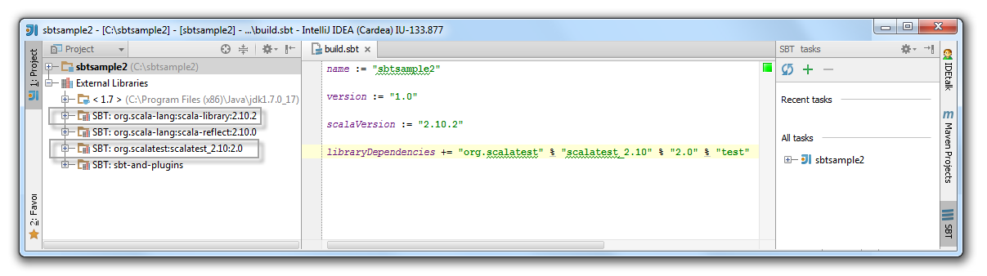  
You will also see the pop-up message suggesting to enable the auto-import option.

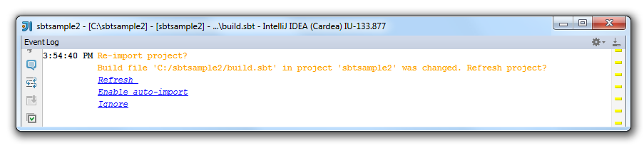

#### 6. Edit SBT Project Settings

IntelliJ IDEA lets you edit the project's settings. This might be helpful if you, for example, didn't specify some options during the project's import.  
To edit your project's settings, on the main menu select File → Settings → Project Settings → SBT.  
The **SBT** page opens. Edit the settings and click **OK**.

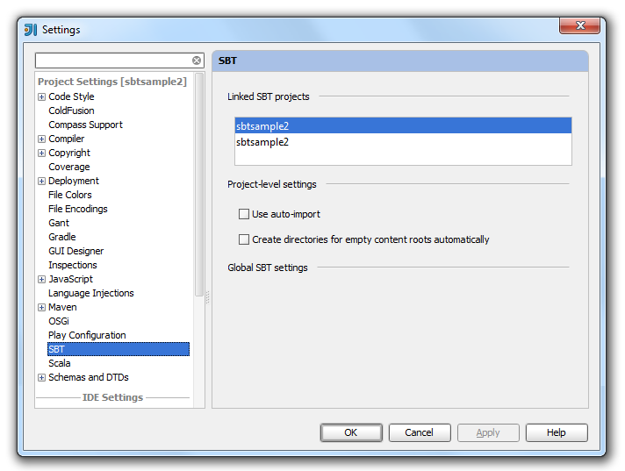

#### [2 Comments](https://confluence.jetbrains.com/display/IntelliJIDEA/Getting+Started+with+SBT)

[comments.show.hide](https://confluence.jetbrains.com/display/IntelliJIDEA/Getting+Started+with+SBT)

1. 

Dec 15, 2014

##### Anonymous

There is no File > Settings menu item.  Doesn't exist.

* + [Permalink](https://confluence.jetbrains.com/display/IntelliJIDEA/Getting+Started+with+SBT?focusedCommentId=57287023#comment-57287023)
  + [Reply](https://confluence.jetbrains.com/pages/replycomment.action?commentId=57287023&pageId=53330077)
  + 

Dec 15, 2014

##### Anonymous

You are not using IntellijIDEA I guess

### [Managing Imports in Scala](https://confluence.jetbrains.com/display/IntelliJIDEA/Managing+Imports+in+Scala)

IntelliJ IDEA lets you manage your imports in Scala the same way as it does in other languages.

You can configure imports in the Project Settings and in the IDE Settings. You can also optimize your imports and exclude classes from auto-import in the editor.

#### 1.Project Settings

You can format your imports using Project Settings.

In the Settings dialog, select Project Settings→Code→Scala→ Imports.

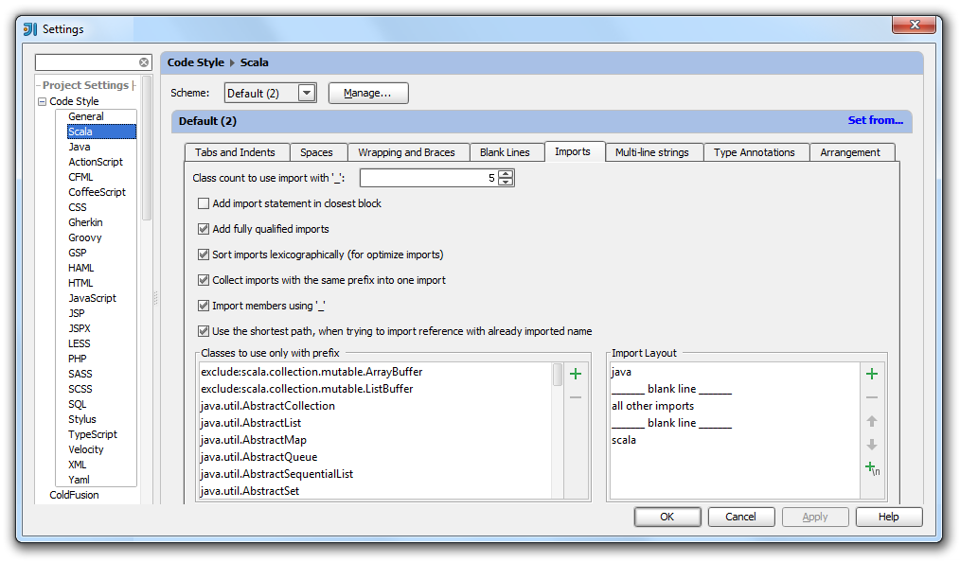

* **Class count to use import with '_'** - in this text field, specify the number of classes to be imported from a single package until all statements importing a single class are substituted with a statement importing an entire package.
* **Add import statement in closest block** - select this check box to add your import statement to the closest block instead of the top of your code.
* **Add fully qualified imports** - select this check box to add fully qualified imports.
* **Sort imports lexicographically (for optimize imports)** - use this check box if you want IntelliJ IDEA to sort your imports in lexicographical order. Note, that if **Add fully qualified imports** check box is selected then fully qualified imports are sorted first.
* **Collect imports with the same prefix into one import** - use this check box if you want IntelliJ IDEA to insert all imports with the same prefix into one.
* **Import members using '_'** - If you select this check box then IntelliJ IDEA imports all members included in the object. If the check box is cleared, IntelliJ IDEA imports only a specific member such as method or a field from the object.
* **Use the shortest path when trying to import reference with already imported name** - select this check box to let IntelliJ IDEA find the shortest available path when you import the reference with already imported name using code completion.
* **Classes to use only with prefix** - this area lets you view the list of classes with prefixes. You can add a pattern to use appropriate classes only with prefix or you can remove a class from the list.
* **Import Layout** - this area lets you view the layout of the import statements, add  or remove  blank lines between them, and add or remove  package names. You can also move the rows in the layout up or down .

#### 2.IDE Settings

You can configure the behavior of the imports in your workspace through the IDE Settings.

In the Settings dialog, select IDE Settings→Editor→Auto Import.

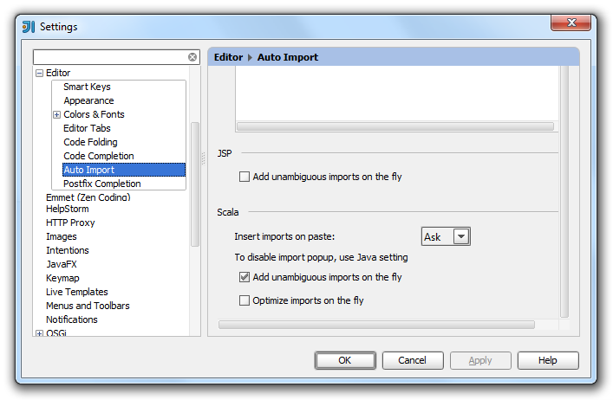

 You can select the following options:

* **Insert imports on paste** - use this drop-down list to define how IntelliJ IDEA will insert imports for pasted blocks of code if they contain references to classes that are not imported into the target class.   
  You can select from the following options:  
  All - select this option to have IntelliJ IDEA automatically add import statements for all classes that are found in the pasted block of code and are not imported in the current class yet.  
  Ask - if this option is selected, when pasting code blocks, IntelliJ IDEA will open a dialog box, where you can choose the desired imports.  
  None - select this option to suppress import.

|  |  |
| --- | --- |
| https://confluence.jetbrains.com/images/icons/emoticons/warning.gif | If you skip an import suggested in the Ask mode or choose the None mode, the non-imported classes will be red-highlighted and an import pop-up window will appear to help you create import statements using the Alt+Enter keyboard shortcut. |

* **Optimize imports on the fly** - select this check box to have the Optimize Imports operation automatically performed for your files. If you clear this check box, you can manually optimize your imports selecting Code →Optimize Imports.
* **Add unambiguous imports on the fly** - select this check box to have IntelliJ IDEA automatically add imports that can be added without user intervention.

#### 3.Optimizing Imports

You can optimize imports selecting Code →Optimize Imports command.

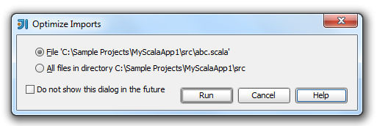

In this dialog box, specify from where you want IntelliJ IDEA to remove unused import statements, in order to optimize the import procedure.

* **File** - click this option to have unused imports removed from the current file. This option is selected by default, if a file in the editor has the focus, or if it is selected in the Project tool window.
* **All files in directory <directory name>** - click this option to have unused imports removed from all files in the current directory at once. This option is selected by default, if a directory is selected in the Project tool window.
* **Do not show this dialog in the future** - select this check box to perform import optimization in the future silently.

#### 4.Excluding Classes from Auto-Import

If the list of suggested imports is too wide, you can exclude unnecessary classes on the fly using intention actions.

Start typing a name in the editor.

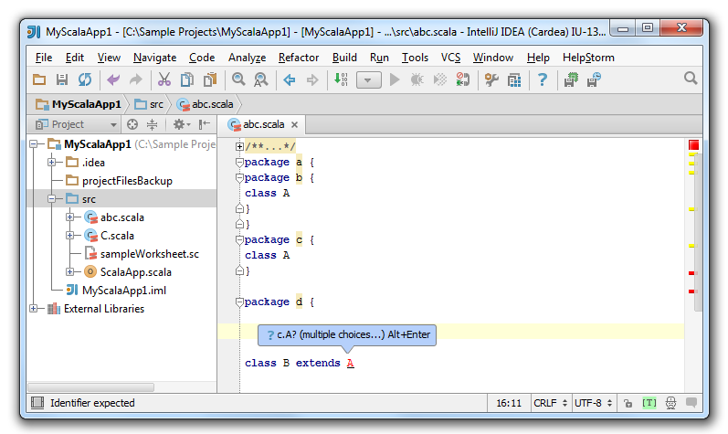

In the **Class to Import** suggestion list, click Alt + Enter, and click the right arrow to reveal the nested list of intention actions. IntelliJ IDEA suggests you to exclude specific class or the whole containing package.

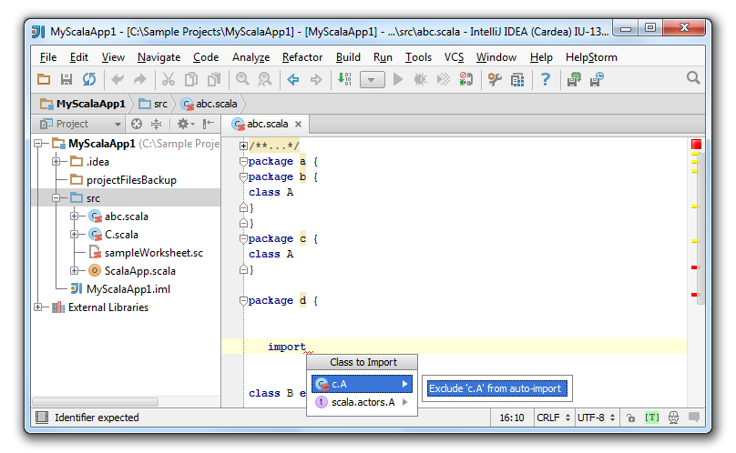

In the dialog that opens perform necessary changes and click **OK**.

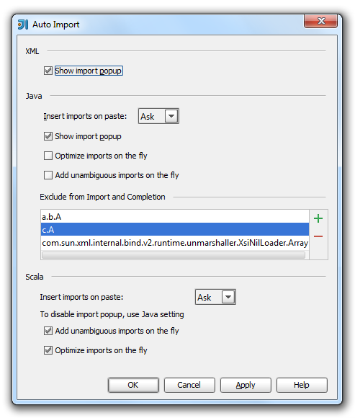

#### [1 Comment](https://confluence.jetbrains.com/display/IntelliJIDEA/Managing+Imports+in+Scala)

[comments.show.hide](https://confluence.jetbrains.com/display/IntelliJIDEA/Managing+Imports+in+Scala)

1. 

Oct 24, 2014

##### Anonymous

There is a bug with the Scala Code Style Import Layout where you cannot restrict a match to exactly the package.  For example, in our project, we import classes from com.escalatesoft.subcut.inject.BindingModule, and we also have a Scala module named "common", so we import common.postgres.dao.DaoImplicits.richPostgresDao.  The Optimize Imports feature will put these two imports together in a section identified by "com" in the Import Layout settings.  But we do not want "com" to match "common".  Entering "com.*" into the Import Layout settings does not work (I guess wildcards are not supported.)

## [Flash Development](https://confluence.jetbrains.com/display/IntelliJIDEA/Flash+Development)

## [Android Development](https://confluence.jetbrains.com/display/IntelliJIDEA/Android+Development)

## [Groovy Development](https://confluence.jetbrains.com/display/IntelliJIDEA/Groovy+Development)

## [Migration](https://confluence.jetbrains.com/display/IntelliJIDEA/Migration)

## [Database Tools](https://confluence.jetbrains.com/display/IntelliJIDEA/Database+Tools)

## [Debugging with Chronon](https://confluence.jetbrains.com/display/IntelliJIDEA/Debugging+with+Chronon)

## [PhoneGap, Cordova and Ionic](https://confluence.jetbrains.com/display/IntelliJIDEA/PhoneGap%2C+Cordova+and+Ionic)

## [Portuguese](https://confluence.jetbrains.com/display/IntelliJIDEA/Portuguese)

# [Plugin Development](https://confluence.jetbrains.com/display/IntelliJIDEA/Plugin+Development)